©



**Online learning**

**Software Requirement Specification**

**Team 2**

– Hanoi, Feb 2023 –

Record of changeS

|  |  |  |  |
| --- | --- | --- | --- |
| Date | A* M, D | In charge | Change Description |
| 28/1 | A | ThangPM | Add screen flow(I.2.a). |
| 01/02 | A | ThangPM | Update screen flow (I.2.a), screen details(I.2.b). |
| 08/02 | A | ThangPM | Add introduction (I.1), screen details(I.2.b), user authorization(I.2.c). |
| 13/02 | A | ThangPM | Add erd (I.3), functional requirements (III). |
| 02/03 | A | ThangPM | Added more screen details(I.2.b) and user authorization(I.2.c). |
| 07/03 | A | ThangPM | Added more screen details(I.2.b), user authoriazation(I.2.c). |
| 13/03 | M | ThangPM | Modified screen flow(I.2.a), screen details,user authorization(I.2.c). |
| 13/03 | A | ThangPM | Added admin screen details(I.2.b). |
| 17/03 | D | ThangPM | Deleted screen details (news, support center)(I.2.b). |
|  |  |  |  |
|  |  |  |  |
|  |  |  |  |

*A - Added M - Modified D - Deleted

**Table of Contents**

I. Overview 5

1. Introduction 5

2. System Functions 5

3. Entity relationship diagram 12

II. Functional requirements 12

1. Public feature 12

a. Home page: 12

b. Pop-up: 15

2. Common feature: 15

a. Sign up: 15

b. Fill information: 16

c. Verify register: 16

d. Sign in: 17

e.Class: 18

f. Course: 19

g. Chapter: 19

h. Module: 20

i. Lession: 21

j. Quiz: 21

k. Video lession: 24

l. Games: 24

m. Payment: 25

n. Confirm payment: 26

o. Email payment: 26

p. User profile: 27

q. Change user profile: 28

r. Change password: 28

s. Ranking: 29

3. Admin feature: 30

a. Manage quiz: 30

b. Manage games: 32

c. Manage video lession: 33

d. Manage content: 34

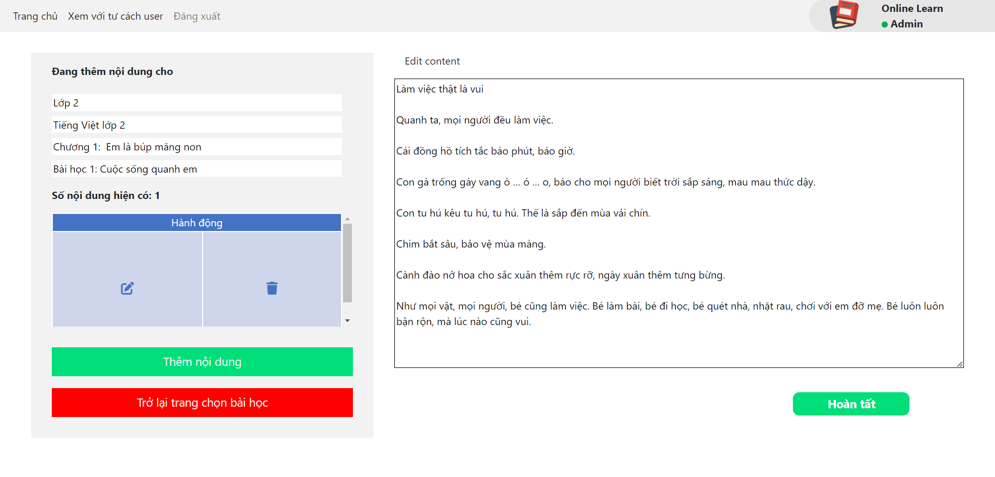 35

e. Manage user: 35

f. Add/modify chapter: 36

g. Add/modify lession: 37

1. Manage quiz…………………………………………………………………………………………
2. Manage games…………………………………………………………………………………….
3. Manage video………………………………………………………………………………………
4. Manage content…………………………………………………………………………………..
5. Manage user………………………………………………………………………………………..
6. Add/modify chapter…………………………………………………………………………….
7. Add/modify lession………………………………………………………………………………

# I. Overview

## 1. Introduction

This project is aimed at Online Learning system which supports for students and parents finding the most suitable course which are maths, literature,

English, etc. All of this course is very easy to use and learn, it has learning-game so the students find it interesting to learn.

## 2. System Functions

#### a. Screen Flow

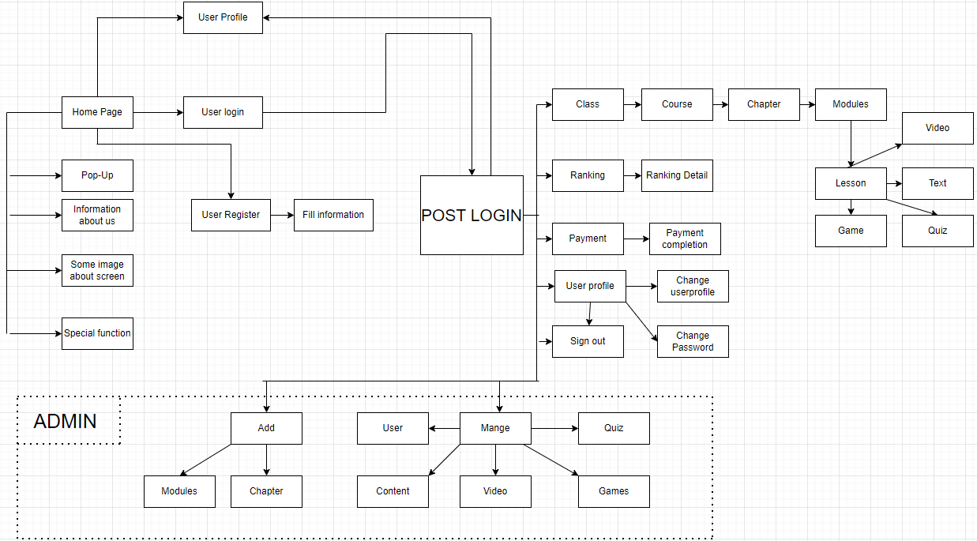

#### b. Screen Details

|  |  |  |  |
| --- | --- | --- | --- |
| **#** | **Feature** | **Screen** | **Description** |
| 1 | Public | Home Page | - Show navigation bar: Home, class, ranking, payment, user profile.  - Show information of web which includes main functions: Learning with quiz, learning with playing games and learning with video.  - Show importance of learning online.  - Show main screen when user learn.  - Show information about team who develop this learning web.  - Show information to contact with our team. |
| 2 | Public | Pop-Up | - Show the notification to user. |
| 3 | Public | Register | - Show navigation bar: Home, class, ranking, payment, profile.  - User need to fill username, password and confirm password valid to sign up account. |
| 4 | Common | Fill information | - Show navigation bar: Home, class, ranking, payment, profile.  - User need to fill information which include: Full name, date of birth, gender, parent’s name, parent’s gmail, phone number to verify. |
| 5 | Common | Verify register | - User receive number code in email and fill the code to verify account.  - The code will invalid after 2 minutes. |
|  | Common | Register successful | - Show notify that user have registered successful and press to home page. |
| 6 | Common | Sign in | - Show navigation bar: Home, class, ranking, payment, profile.  - User need to fill their username and password to access their account. |
| 7 | Common | Sign in complete | - Show notify that user access account successfully and press to home page. |
| 8 | Common | Class | - Show navigation bar: Home, class, ranking, payment, profile.  - Show all of the class from grade 1 to grade 5.  - User can choose the suitable class that they want to learn. |
| 9 | Common | Course | - Show navigation bar: Home, class, ranking, payment, profile.  - Show all of the course of the class (maths, literature, english).  - User can choose one of three subjects to learn. |
| 10 | Common | Chapter | - Show navigation bar: Home, class, ranking, payment, profile.  - Show all chapter of subject that user can choose to learn.  - Show percent of learning of subject. |
| 11 | Common | Module | - Show navigation bar: Home, class, ranking, payment, profile.  - Show all module of chapter of subject that user can choose to learn.  - Show percent of learning this chapter of subject. |
| 12 | Common | Lesson | - Show navigation bar: Home, class, ranking, payment, profile.  - Show all of lesson which include: Exercises, game, video, theory. |
| 13 | Common | Quiz | - Show navigation bar: Home, class, ranking, payment, profile.  - User can press to start excercises.  - User need to read and follow the rules of this excercises.  - User need to answer all of the questions to finish the excercises.  - User can re-do excercises.  - After doing quiz, user receive their point. |
| 14 | Common | Video | - Show navigation bar: Home, class, ranking, payment, profile.  - Show video that user can watch to learn. After watching video, user can do excercises and play game. |
| 15 | Common | Ranking | - Show navigation bar: Home, class, ranking, payment, profile.  - Show ranking point, index.  - User can search by name to find their ranking and point. |
| 16 | Common | Games | - Show navigation bar: Home, class, ranking, payment, profile.  - Press start to start playing game.  - Click image to right image to have point.  - After 100 second, the game will finish and caculate pointn you have. |
| 17 | Common | Payment | - Show navigation bar: Home, class, ranking, payment, profile.  - Show transaction of user to pay for premium account which include visa, credit card, paypal.  - User need to fill the right number of their card.  - Show the advantages of premium account.  - Show the total price of premium account per year and VAT |
| 18 | Common | Confirm payment | - This screen notifies to user to enter code which have 6 numbers. The code is in their email that we sent to.  -User need to fill the code in 2 minutes or the code will be expired. |
| 19 | Common | Email payment | - This screen notifies to user that user have to fill email to confirm to pay  -User need to fill their email address and click to send code to pay |
| 20 | Common | Payment success | - Notify to user that payment success and upgrade to premium. |
| 21 | Common | Fail payment | - This screen notifies to user that user have failed to pay.  -User can choose try again or cancel |
| 22 | Common | User profile | - Show navigation bar: Home, class, ranking, payment, profile.  - Show all information about user which include: Full name, date of birth, gender, parent’s name, parent’s email, phone number, user id, type of account. |
| 23 | Common | Change user profile | - Show navigation bar: Home, class, ranking, payment, profile.  - User can change information which include: Full name, gender, date of birth, parent’s name, parent’s email, phone number, user id, type of account.  - User press save to save new information. |
| 24 | Common | Change pasword | - Show form which include old password, new password, confirm new password.  - User need to fill valid password. |
| 25 | Admin | Manage quiz | - Show form which admin choose class, course, chapter, lession that admin want to add or delete quiz.  - After fill the form, admin press “Hoàn Tất” to add quiz.  - After choose question, admin press “Xác nhận và xóa” to delete quiz. |
| 26 | Admin | Manage games | - Show form which admin choose class, course, chapter, lession that admin want to add pictures for game.  - After fill the form, admin press “Hoàn tất” to add pictures. |
| 27 | Admin | Manage video | - Show form which admin choose class, course, chapter, lession that admin want to add video lession.  - After fill the form, admin press “Hoàn tất” to add video lession. |
| 28 | Admin | Manage content | - Show form which admin choose class, course, chapter, lession that admin want to add/edit content.  - After fill the form, admin press “Hoàn tất” to add content or edit content. |
| 29 | Admin | Manage user | - Show total account which include normal account and premium account.  - Show list of account information which include: Full name, date of birth, gender, parent’s full name, parent’s email, parent’s phone number and usernamme.  - Admin can search by name account. |
| 30 | Admin | Add/modify chapter | - Show form which admin choose class, course, chapter that admin want to add or modify chapter.  - After fill the form, admin press “Hoàn tất” to add or modify chapter. |
| 31 | Admin | Add/modify module | - Show form which admin choose class, course, chapter that admin want to add or modify module. - After fill the form, admin press “Hoàn tất” to add or modify module. |

#### c. User Authorization

|  |  |  |  |  |
| --- | --- | --- | --- | --- |
| Screen | Guest | Normal User | Premium User | Admin |
| Home page | X | X | X |  |
| Pop-Up | X | X | X | X |
| Sign up | X | X | X |  |
| Fill information | X | X | X |  |
| Verify register | X | X | X |  |
| Login |  | X | X | X |
| Class |  | X | X | X |
| Course |  | X | X | X |
| Chapter |  | X | X | X |
| Module |  | X | X | X |
| Lesson |  | X | X | X |
| Quiz |  | X | X | X |
| Video lession |  | X | X | X |
| Theory lession |  | X | X | X |
| Games |  |  | X | X |
| Payment |  | X | X | X |
| Confirm payment |  | X | X | X |
| Email payment |  | X | X | X |
| Payment success |  | X | X | X |
| Fail payment |  | X | X | X |
| User profile |  | X | X |  |
| Change user profile |  | X | X |  |
| Change password |  | X | X |  |
| Ranking |  |  | X | X |
| Manage quiz |  |  |  | X |
| Manage games |  |  |  | X |
| Manage video lession |  |  |  | X |
| Manage content |  |  |  | X |
| Manage user |  |  |  | X |
| Add/modify chapter |  |  |  | X |
| Add/modify lession |  |  |  | X |

In which:

- Admin: the organization leader/manager, acts as the system administrator. Admin manage quiz, games, video lession, content, user and add or modify chapter, lession. Admin can join web by role as user.

- Customer: + Parents: They are registered users who find the system, choose and register for their childrens.They also the person who pay for premium account.

+ Students: They are users who experience the system. Students can learn any course, do quiz, watch video lession. If their account are upgraded to premium account, they can view ranking and play games.This is potiental user.

- Guest: Unregistered users who can view home page.

#### d. Non-Screen Functions

|  |  |  |  |
| --- | --- | --- | --- |
| **#** | **Feature** | **System Function** | **Description** |
| 1 | Common | User Authentication | Implementation of authorization mechanism in the system, including the specify the role of logged-in user, his/her authorized page links (building the displayed menu items (in the front end) and preventing unauthorized access via enter the links directly). |
| 2 | Common | Usability | It is easy to use for childrens because all object’s name same with the function this object do. |

## 3. Entity relationship diagram

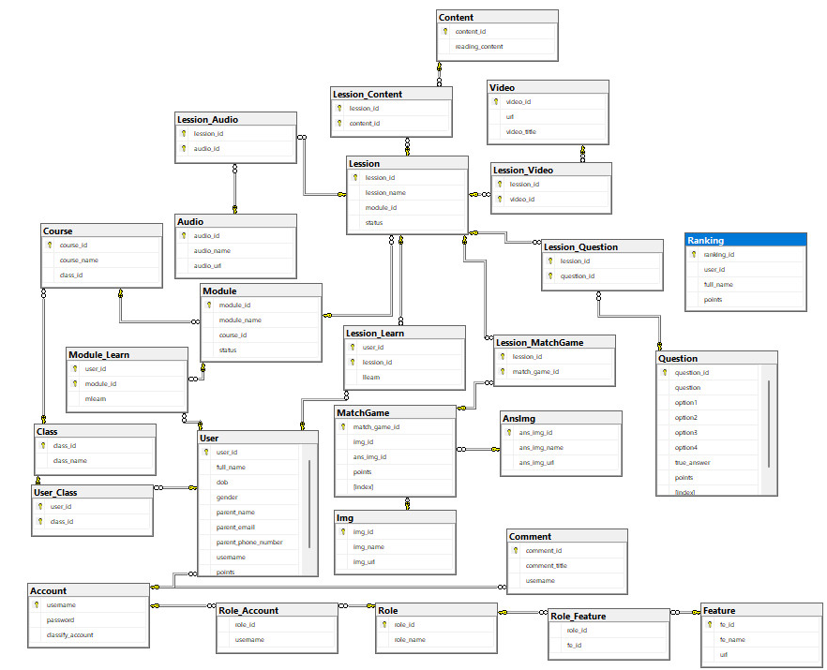

# II. Functional requirements

## 1. Public feature

### a. Home page:

* Function trigger: Direct access via link .
* Function description:
  + User roles will have access to this screen.
  + Show navigation bar: Home, class, ranking, payment, user profile.
  + Show information of web which includes main functions: Learning with quiz, learning with playing games and learning with video.
  + Show importance of learning online.
  + Show main screen when user learn.
  + Show information about team who develop this learning web.
  + Show information to contact with our team.

Screen layout:

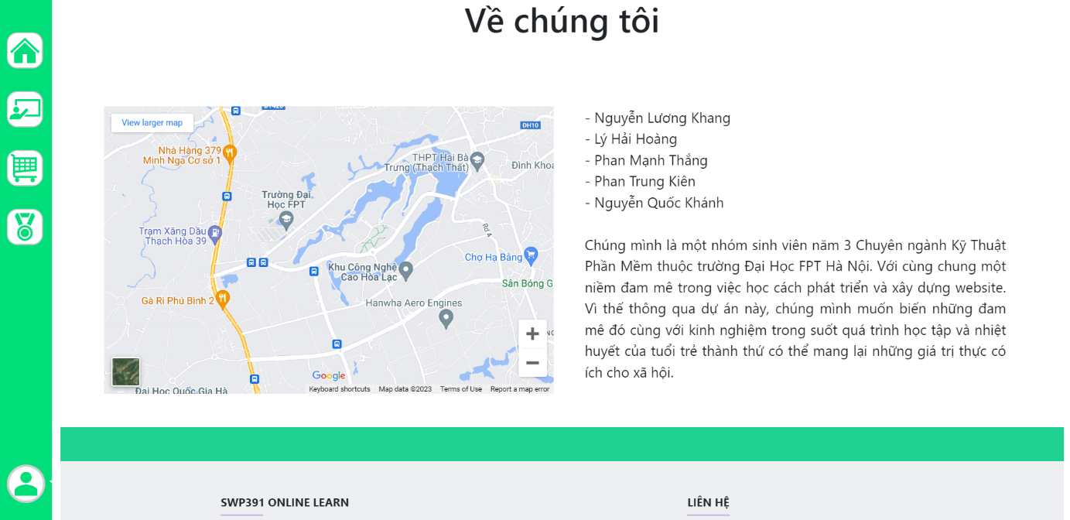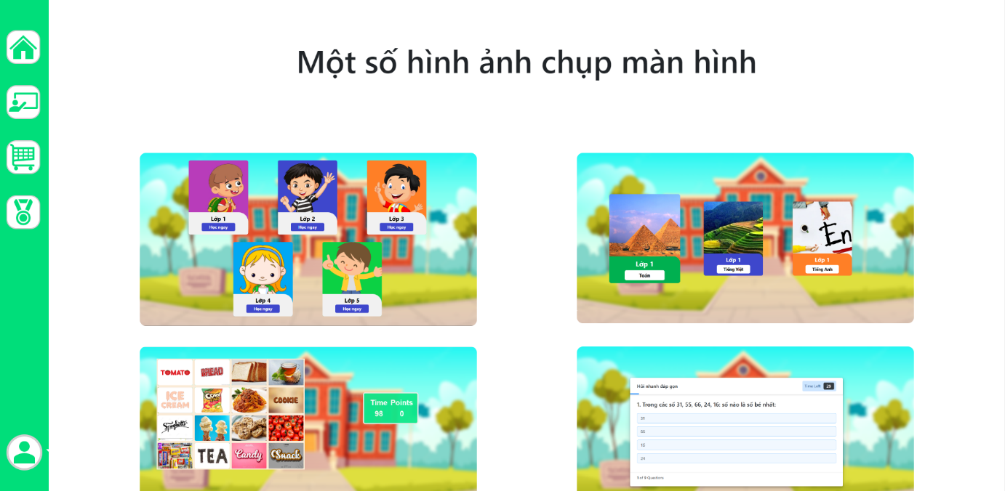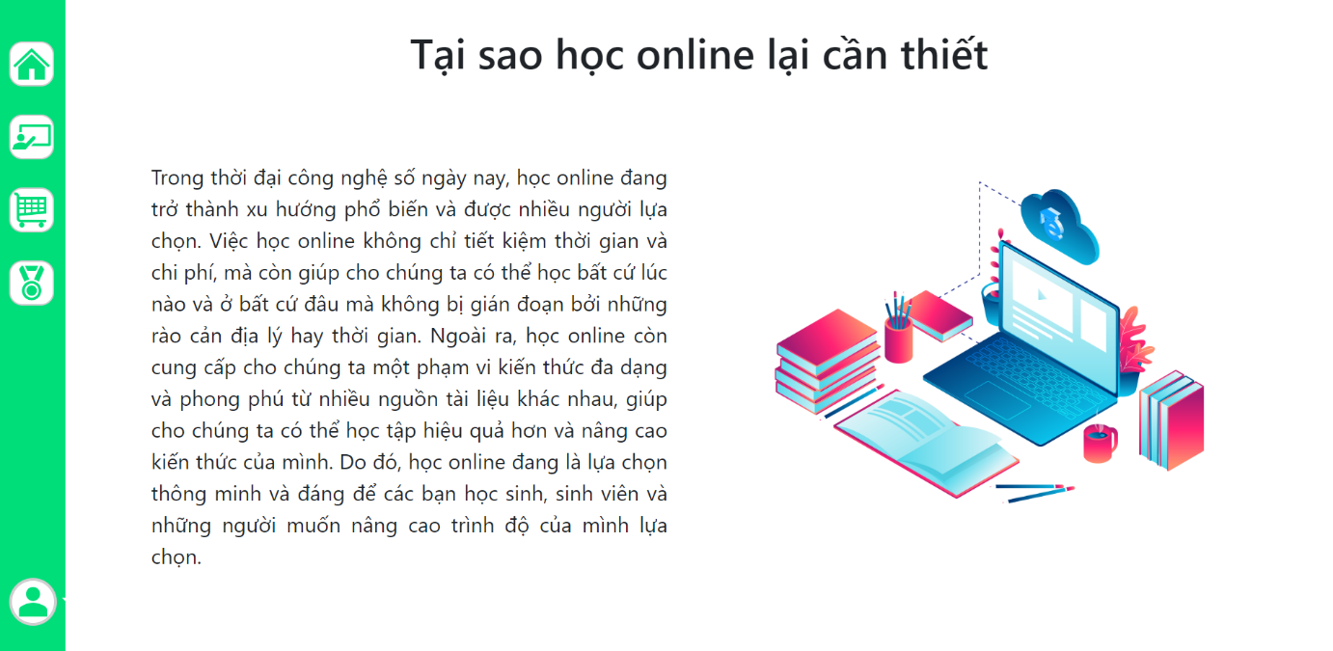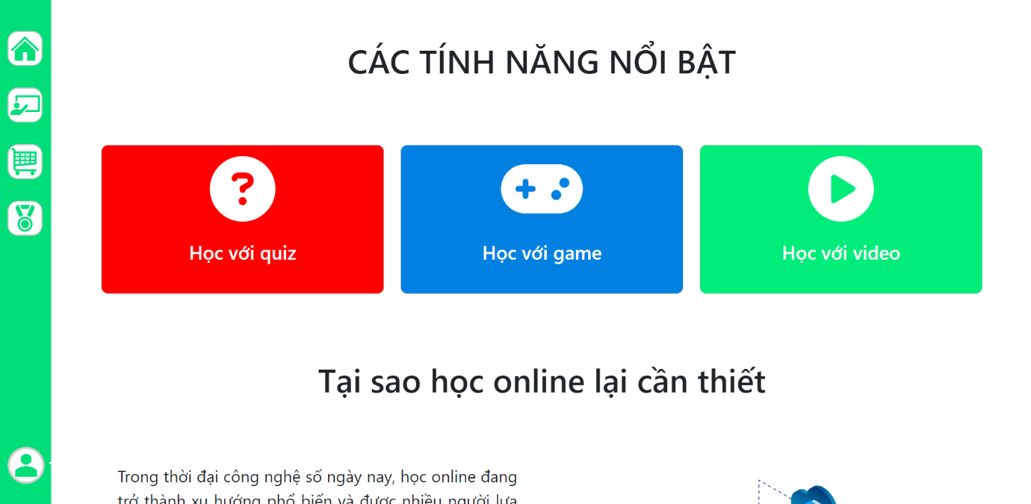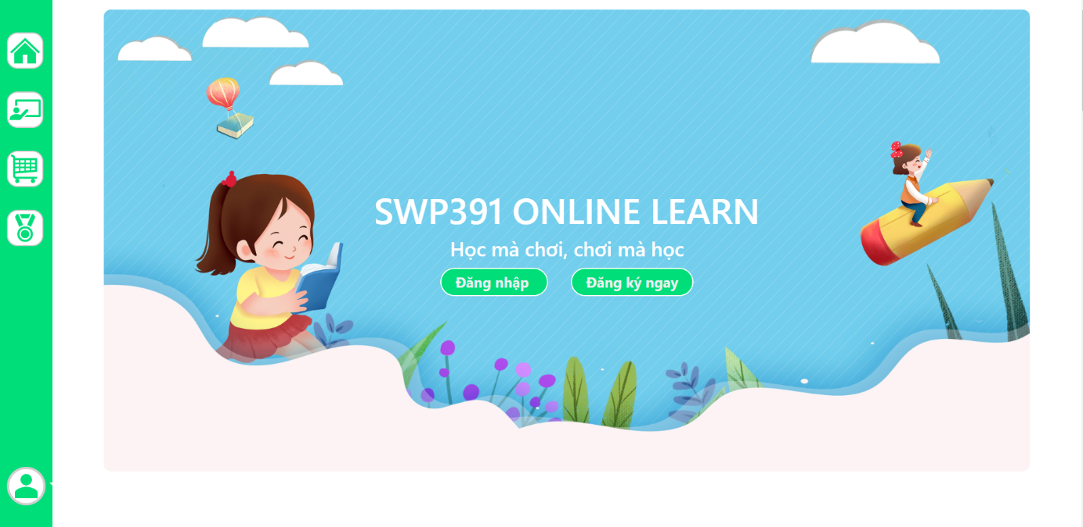

### b. Pop-up:

* Function trigger: Automation appear when user go to Home Page.
* Function description:

- Customer roles will have access to this screen.

- This screen show the important notification to user.

Screen layout:

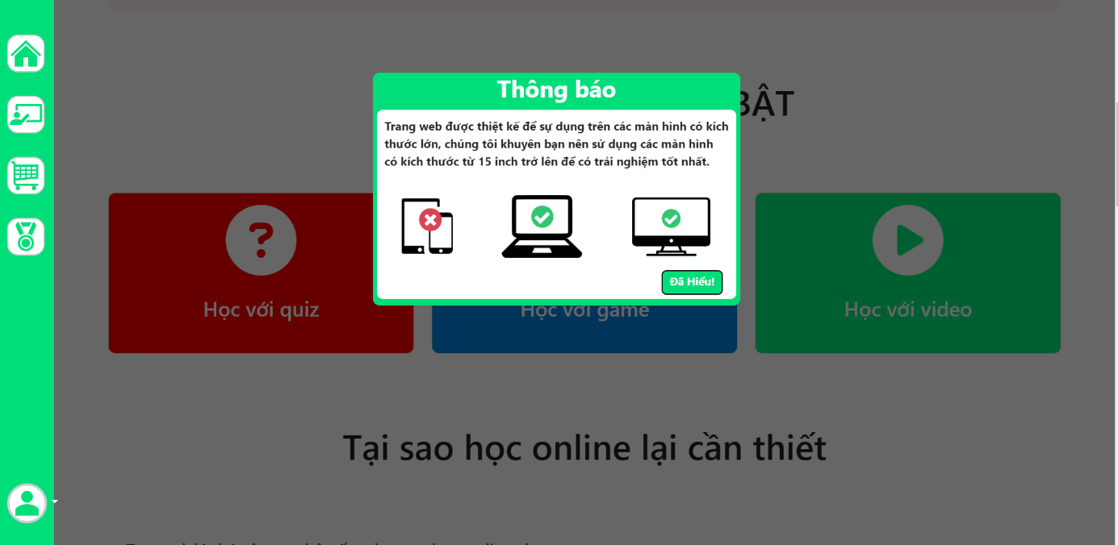

## 2. Common feature:

### a. Sign up:

* Function trigger: When user click “Đăng kí ” at home page.
* Function description:

- Customer roles will have access to this screen.

- Show navigation bar: Home, class, ranking, payment, profile.

- User need to fill username, password and confirm password valid to sign up account.

Screen layout:

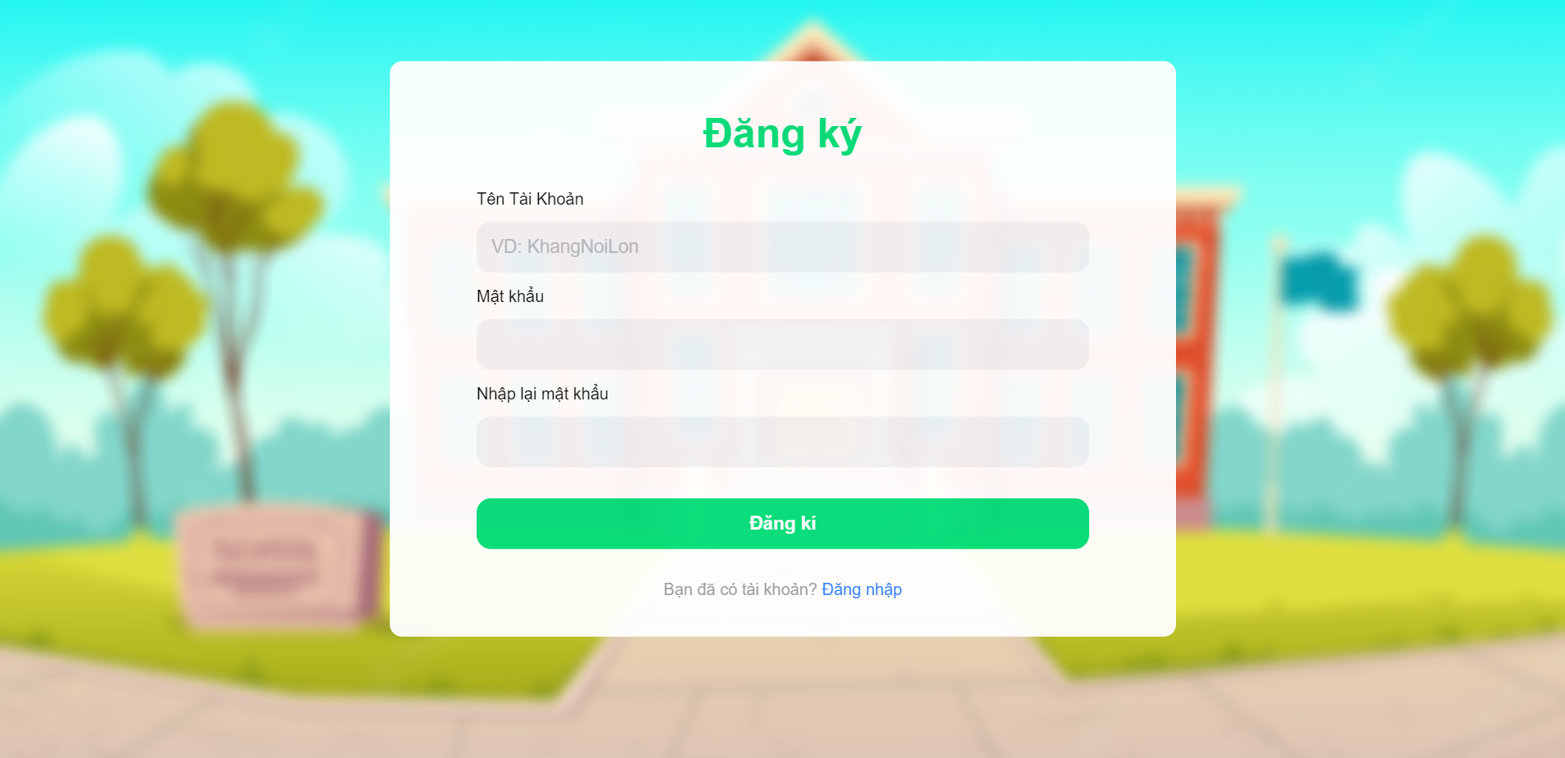

### b. Fill information:

* Function trigger: When user click “Đăng kí ” at home page and sign up success.
* Function description:

- Customer roles will have access to this screen.

- Show navigation bar: Home, class, ranking, payment, profile.

- User need to fill information which include: Full name, date of birth, gender, parent’s name, parent’s gmail, phone number to verify.

Screen layout:

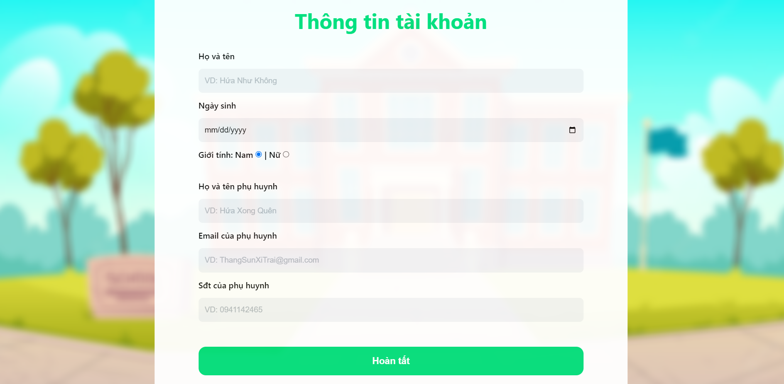

### c. Verify register:

* Function trigger: When user click “Đăng kí ” at home page, sign up and fill information success, user will receive code to verify email.
* Function description:

- Customer roles will have access to this screen.

- User receive number code in email and fill the code to verify account.

- The code will invalid after 2 minutes.

Screen layout:

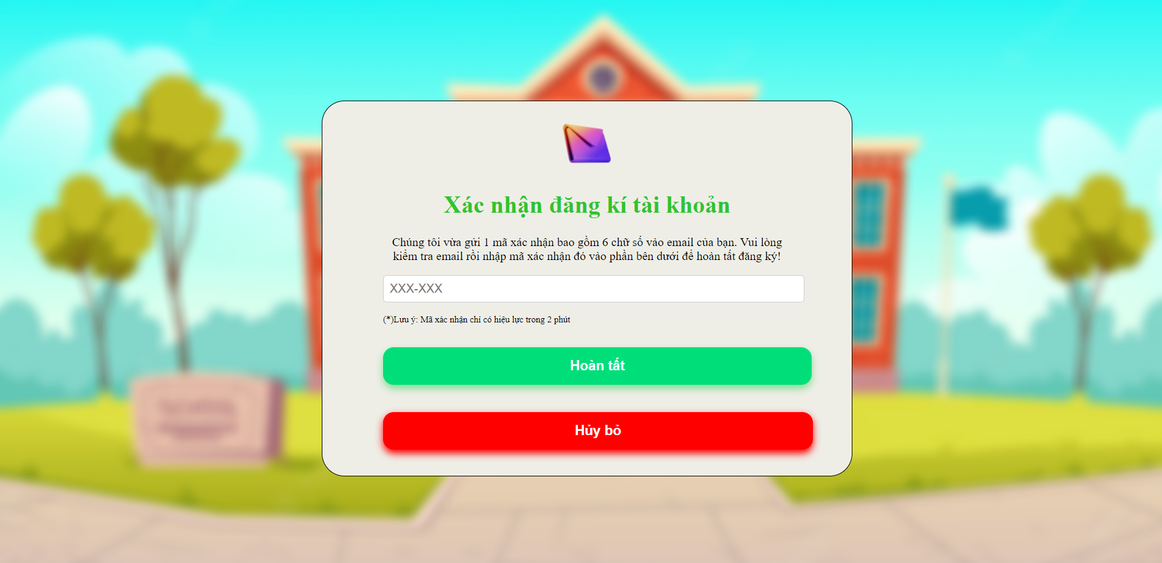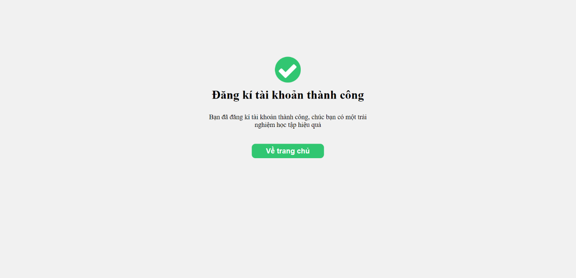

### d. Sign in:

* Function trigger: When user click “Đăng nhập” at home page.
* Function description:

- Customer roles will have access to this screen.

- Show navigation bar: Home, class, ranking, payment, profile.

- User need to fill their username and password to access their account.

Screen layout:

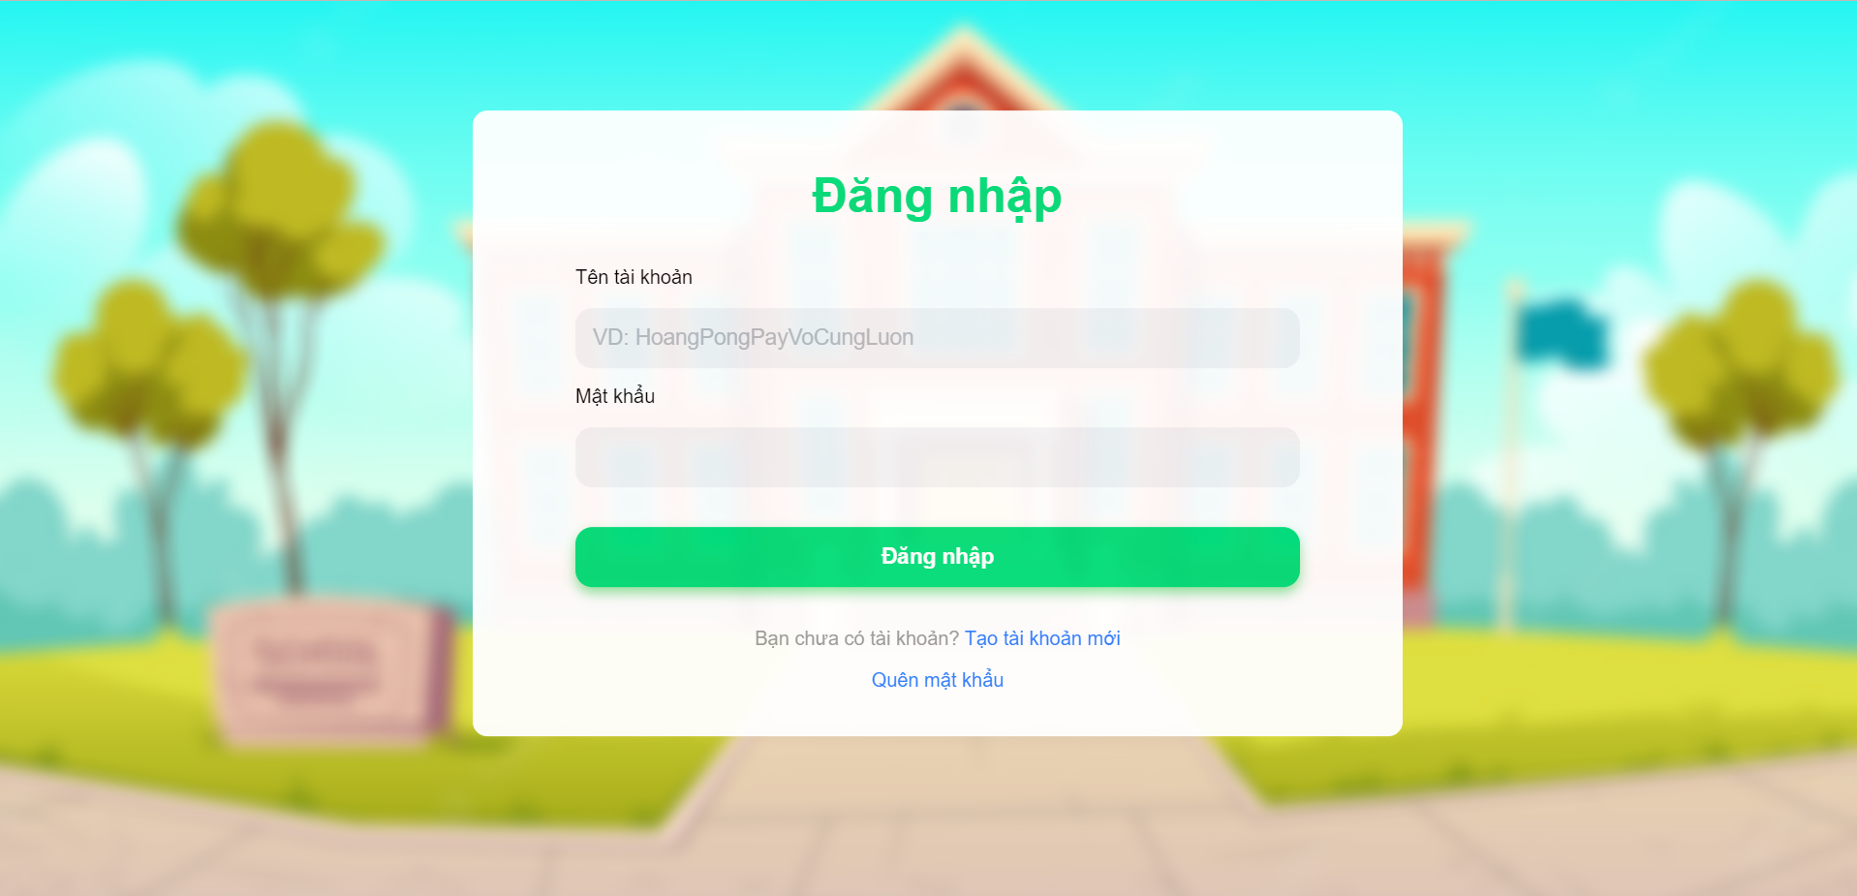

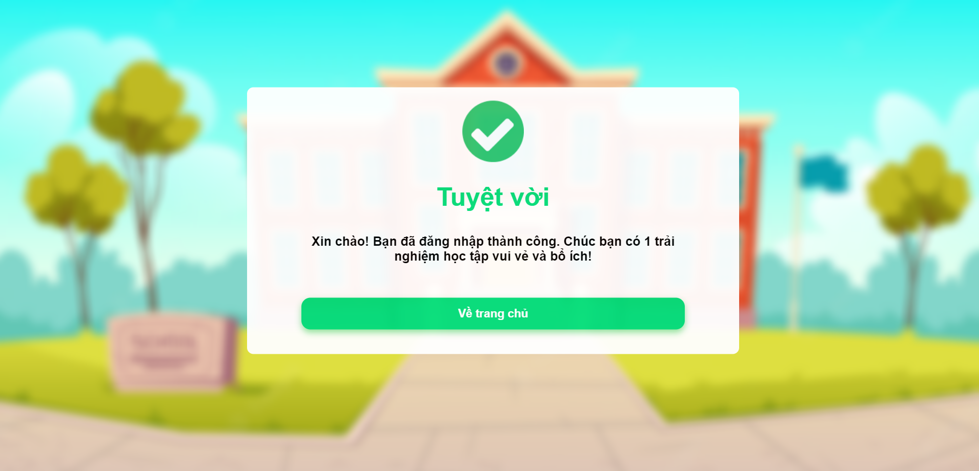

### e.Class:

* Function trigger: When user click to CLASS on navigation bar.
* Function description:

- Customer roles will have access to this screen.

- Show navigation bar: Home, class, ranking, payment, profile.

- Show all of the class from grade 1 to grade 5.

- User can choose the suitable class that they want to learn.

Screen layout:

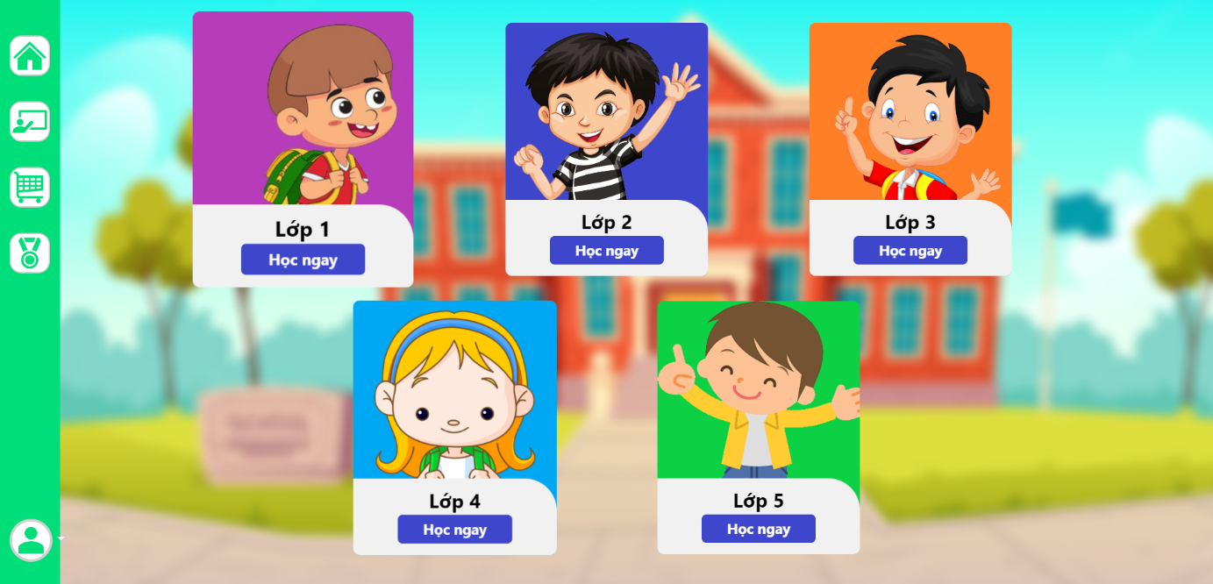

### f. Course:

* Function trigger: When user click to CLASS on navigation bar and choose their course they want .
* Function description:

- Customer roles will have access to this screen.

- Show navigation bar: Home, class, ranking, payment, profile.

- Show all of the course of the class (maths, literature, english).

- User can choose one of three subjects to learn.

Screen layout:

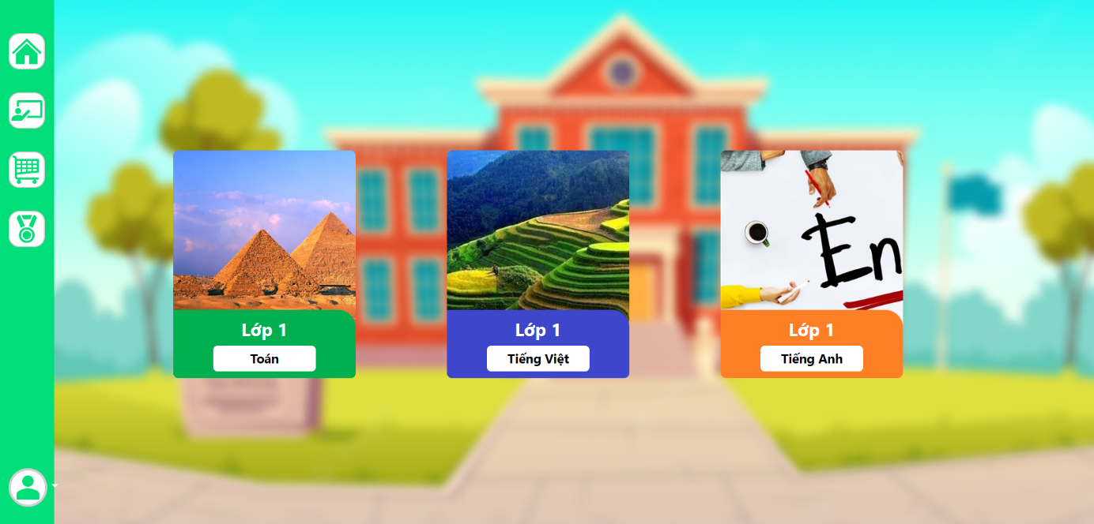

### g. Chapter:

* Function trigger: After choose course, user can choose chapter they want to learn.
* Function description:

- Customer roles will have access to this screen.

- Show navigation bar: Home, class, ranking, payment, profile.

- Show all chapter of subject that user can choose to learn.

- Show percent of learning of subject.

Screen layout:

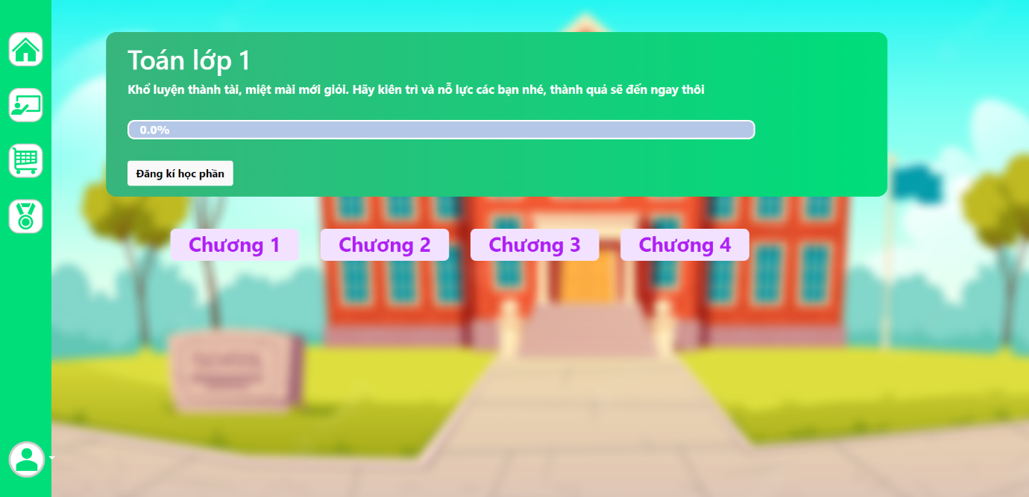

### h. Module:

* Function trigger: After choose chapter, user can choose module they want to learn.
* Function description:

- Customer roles will have access to this screen.

- Show navigation bar: Home, class, ranking, payment, profile.

- Show all module of chapter of subject that user can choose to learn.

- Show percent of learning this chapter of subject.

Screen layout:

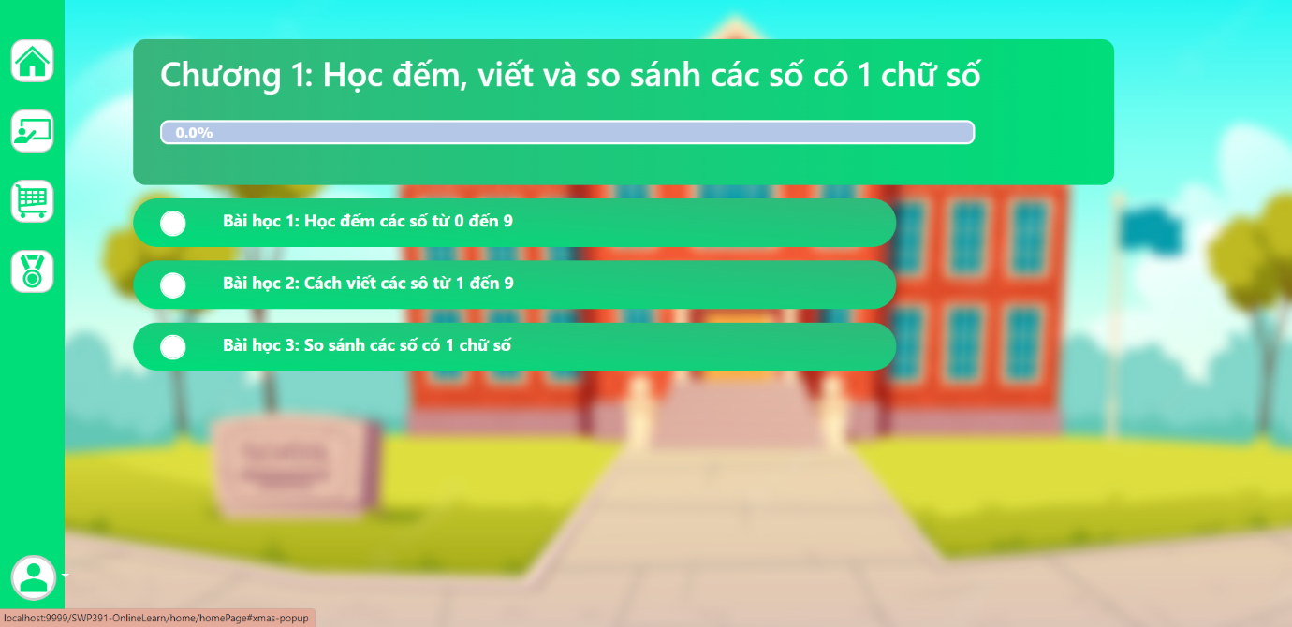

### i. Lession:

* Function trigger: After choose module, user can choose lession they want to learn.
* Function description:

- Customer roles will have access to this screen.

- Show navigation bar: Home, class, ranking, payment, profile.

- Show all of lesson which include: Exercises, game, video, theory.

Screen layout:

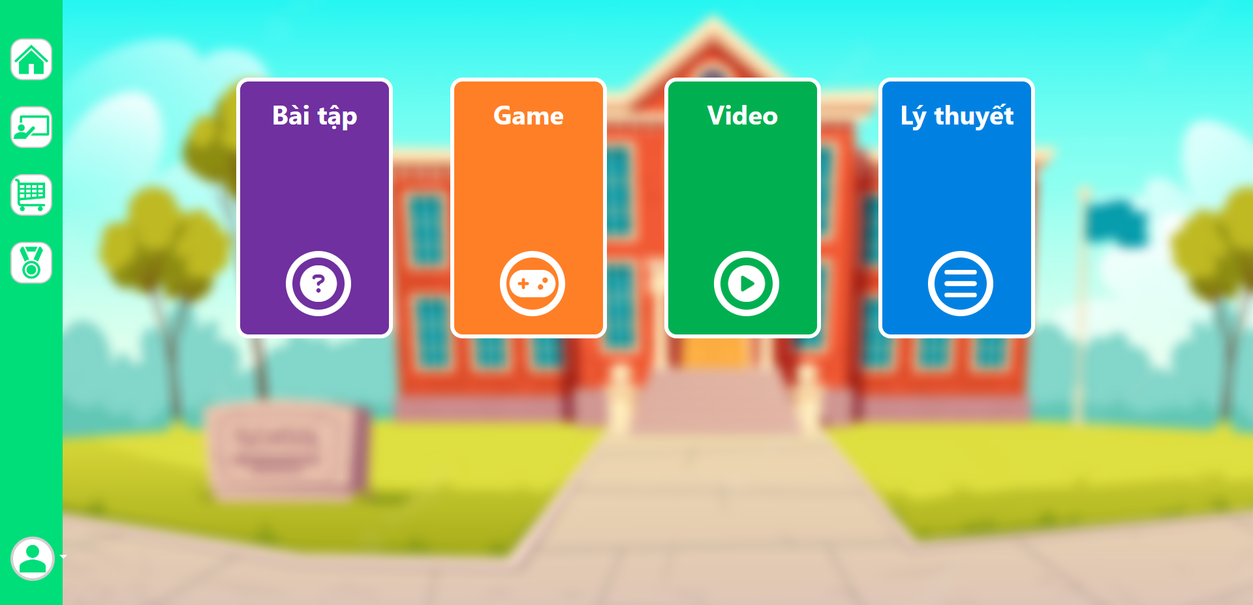

### j. Quiz:

* Function trigger: After choose lession, user can choose quiz to do.
* Function description:

- Customer roles will have access to this screen.

- Show navigation bar: Home, class, ranking, payment, profile.

- User can press to start excercises.

- User need to read and follow the rules of this excercises.

- User need to answer all of the questions to finish the excercises.

- User can re-do excercises.

- After doing quiz, user receive their point.

Screen layout:

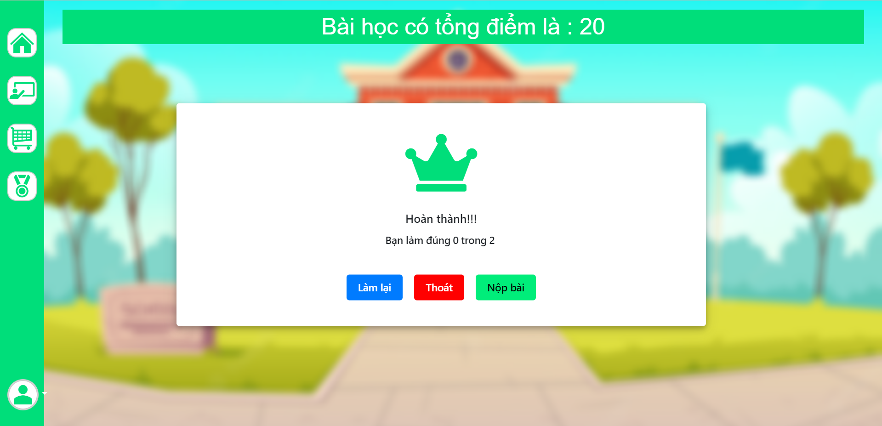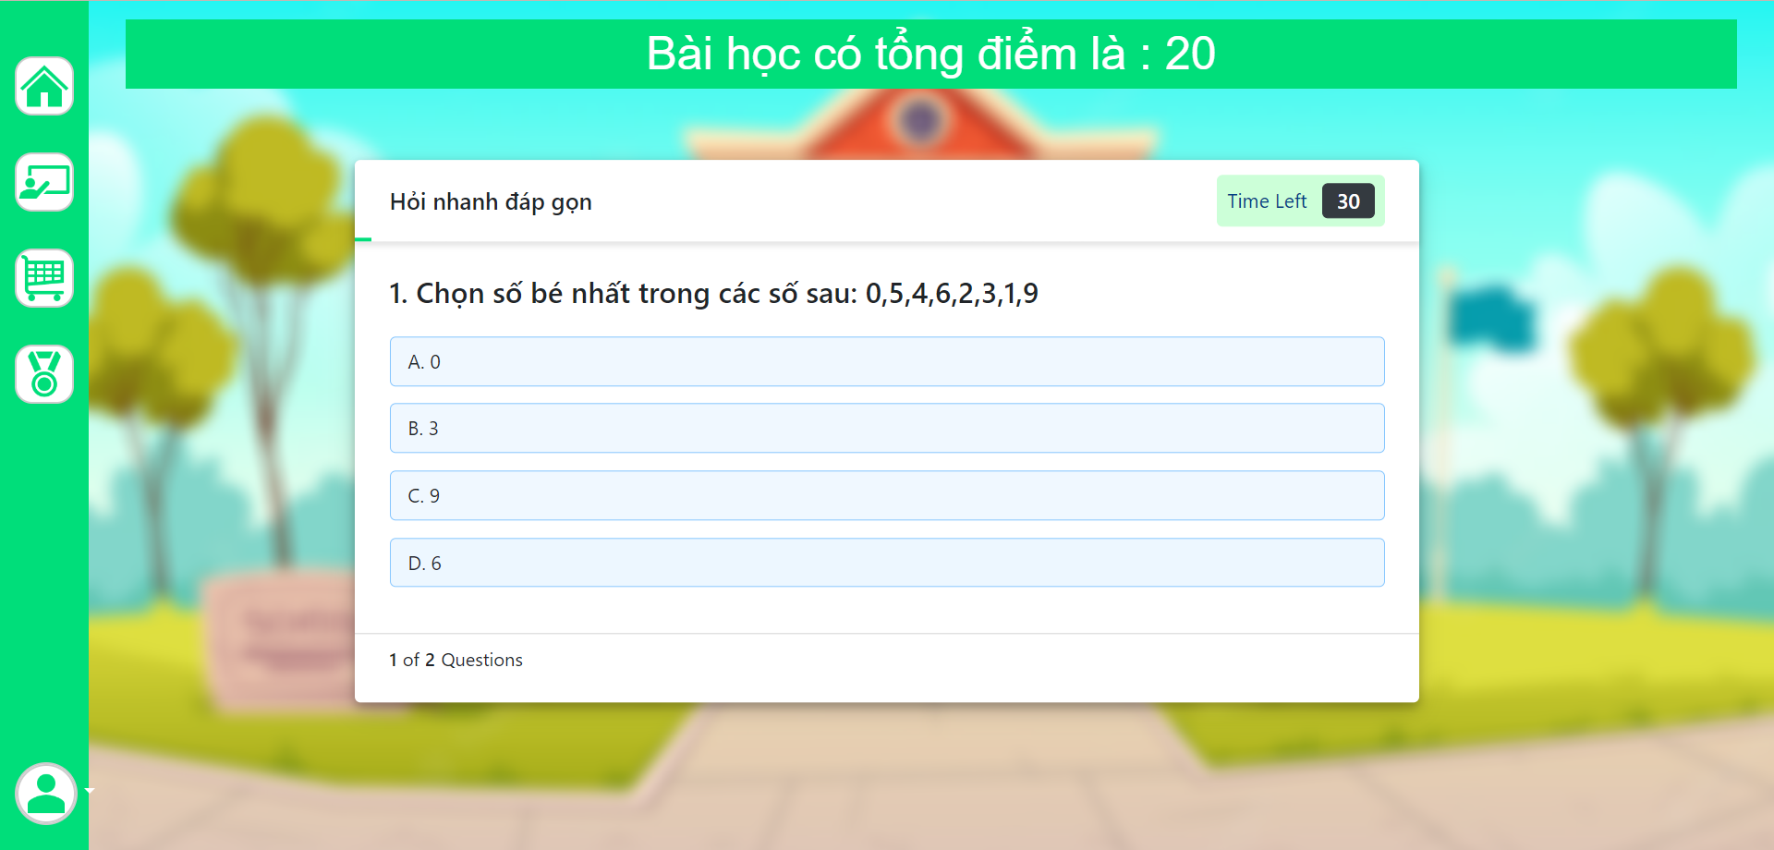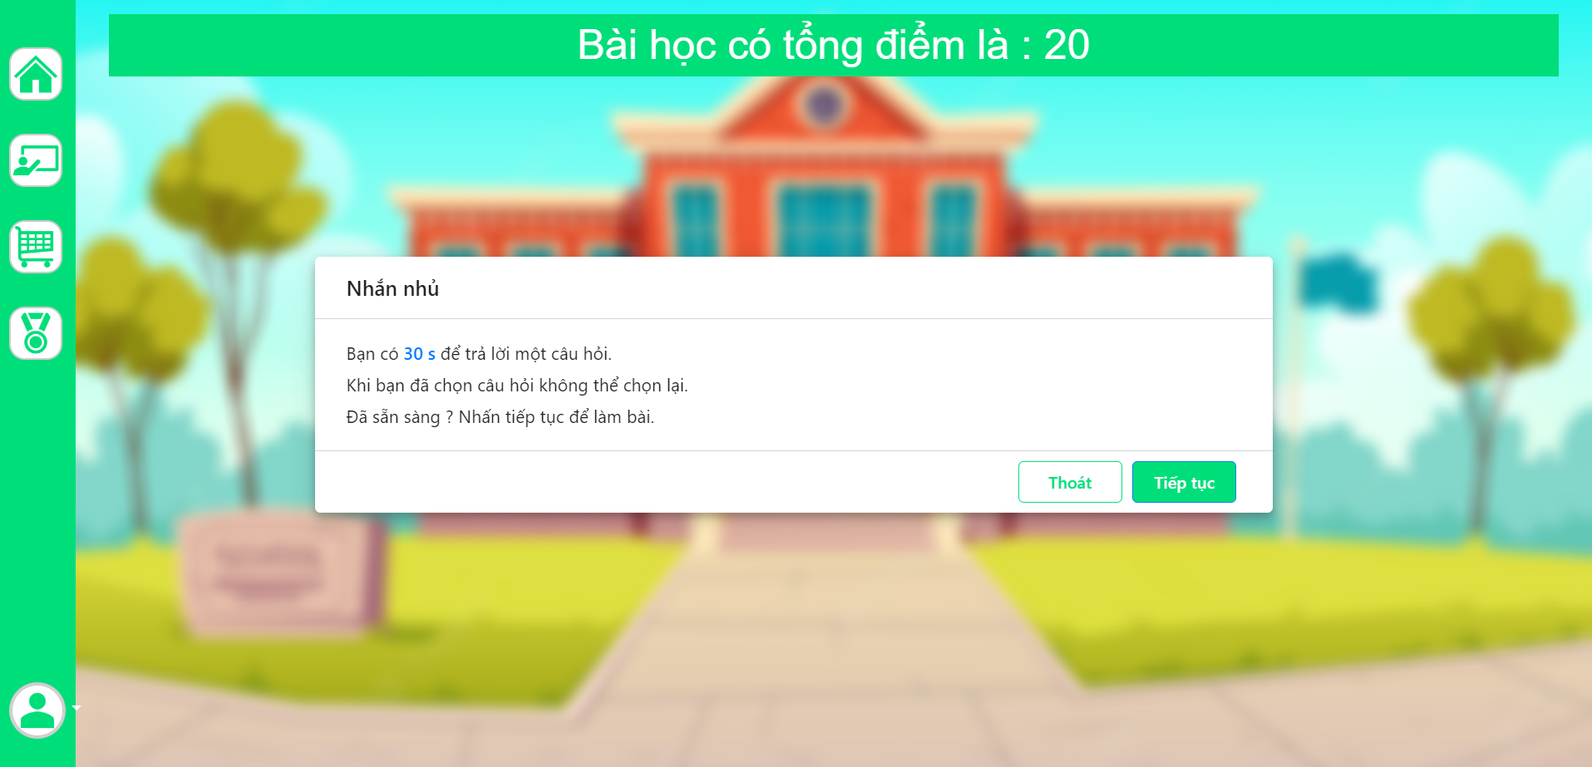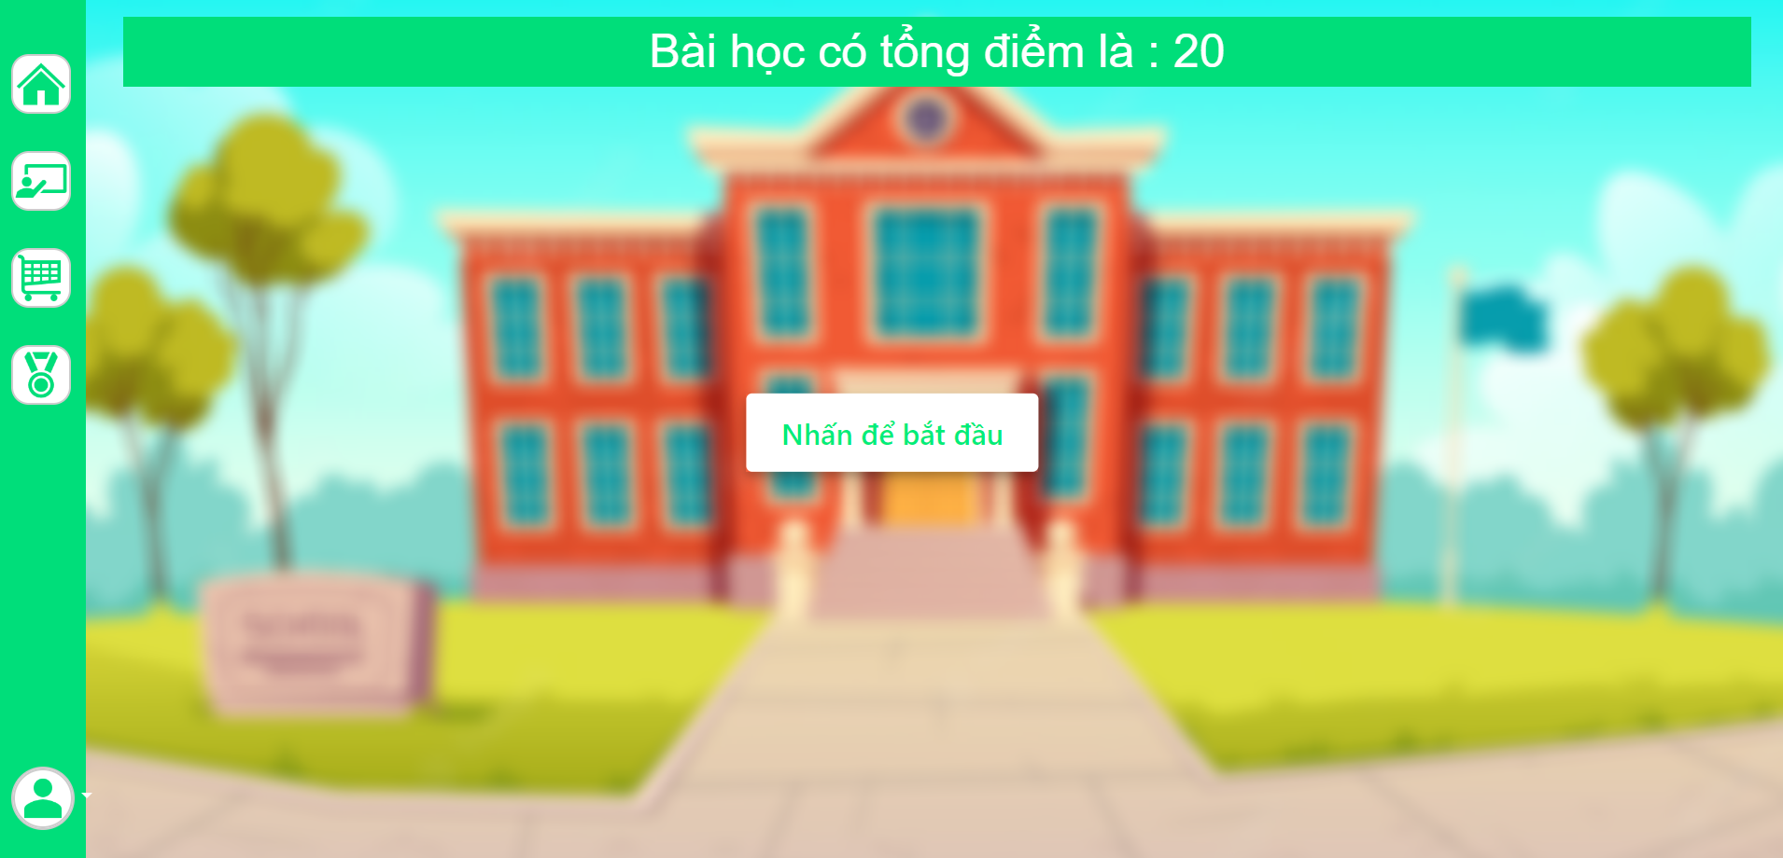

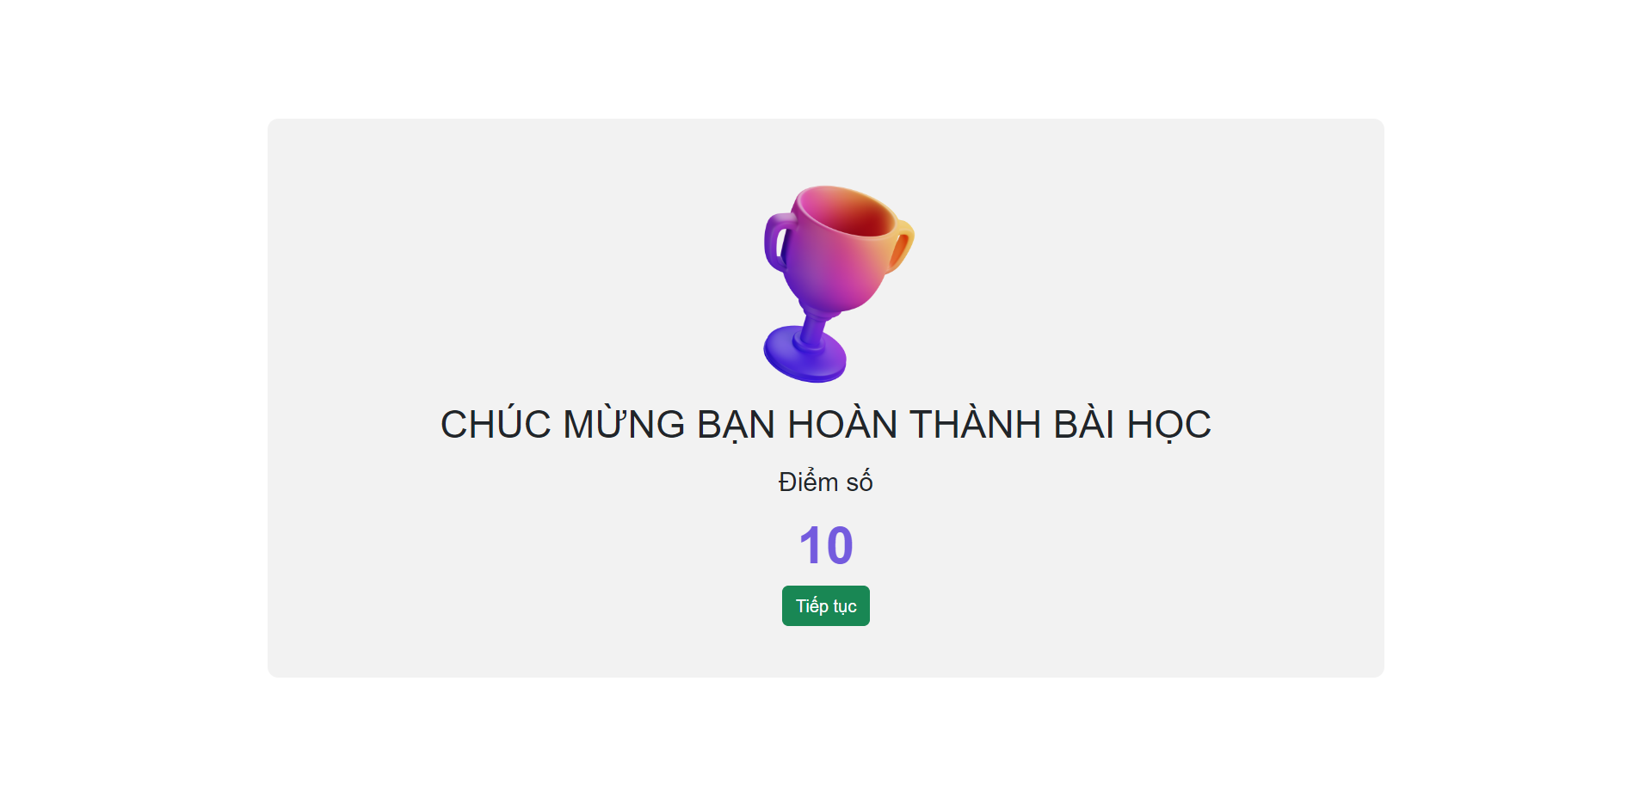

### k. Video lession:

* Function trigger: After choose lession, user can choose video lession to learn.
* Function description:

- Customer roles will have access to this screen.

- Show navigation bar: Home, class, ranking, payment, profile.

- Show video that user can watch to learn. After watching video, user can do excercises and play game.

Screen layout:

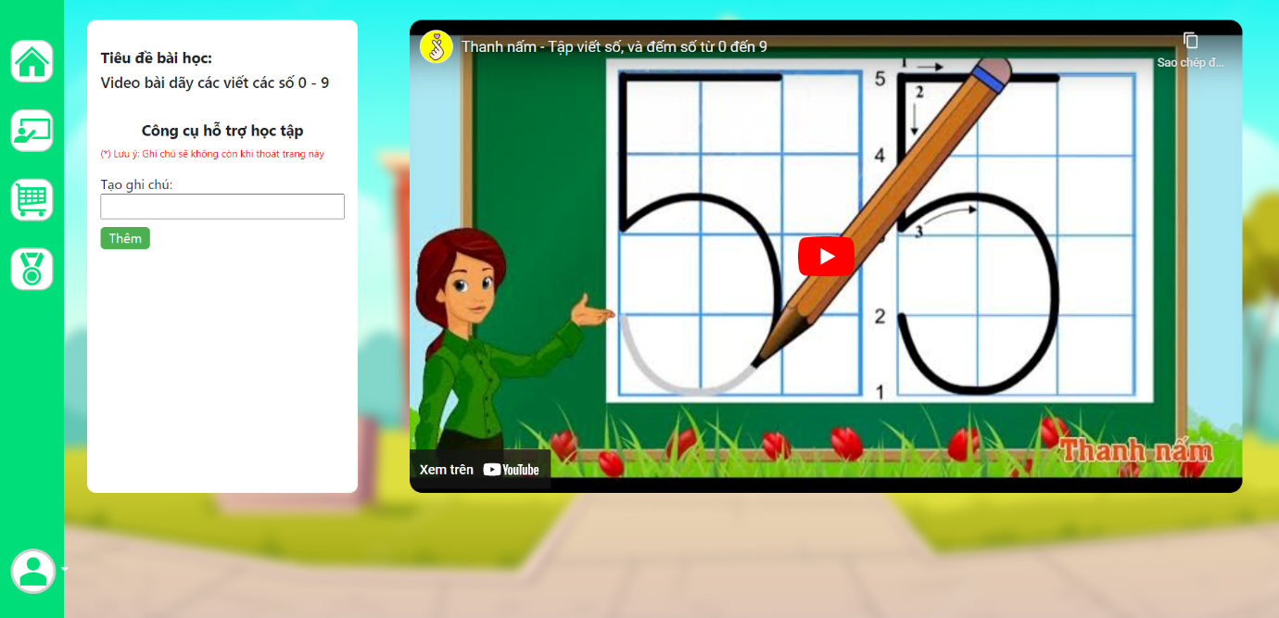

### l. Games:

* Function trigger: After choose lession, user can choose games to do.
* Function description:

- Customer roles will have access to this screen.

- Show navigation bar: Home, class, ranking, payment, profile.

- Press start to start playing game.

- Click image to right image to have point.

- After 100 second, the game will finish and caculate pointn you have.

Screen layout:

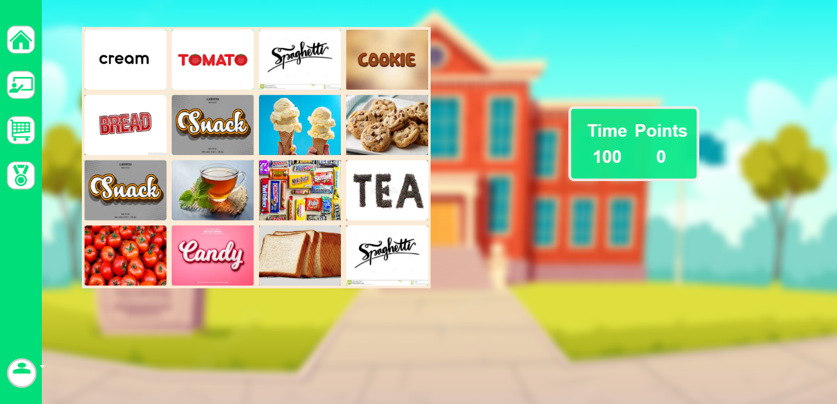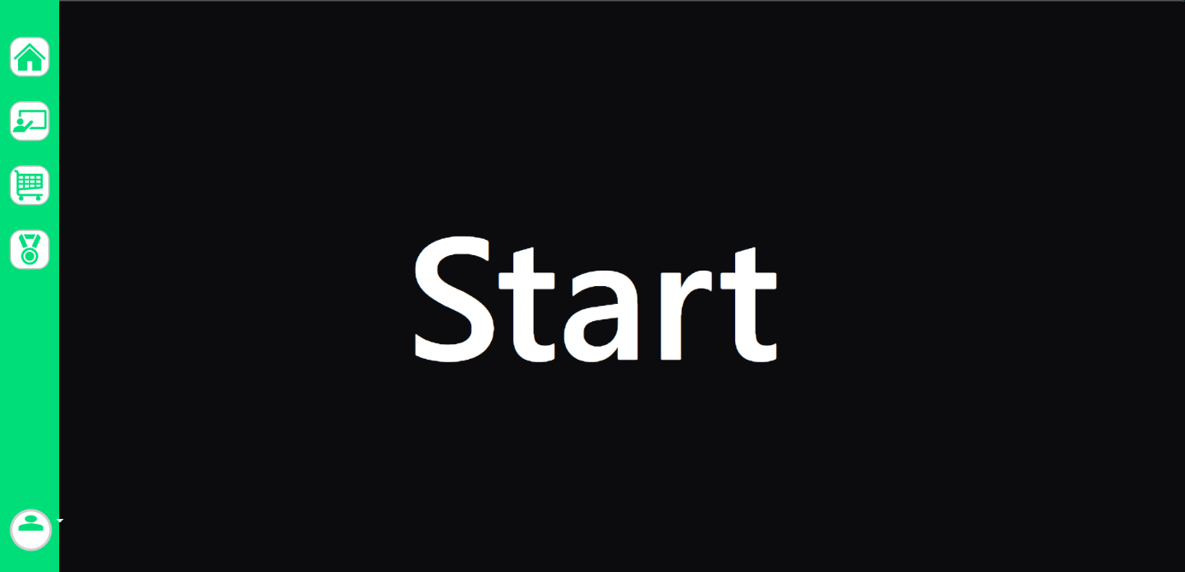

### m. Payment:

* Function trigger: When user click “Payment ” at navigation bar.
* Function description:

- Customer roles will have access to this screen.

- Show navigation bar: Home, class, ranking, payment, profile.

- Show transaction of user to pay for premium account which include visa, credit card, paypal.

- User need to fill the right number of their card.

- Show the advantages of premium account.

- Show the total price of premium account per year and VAT.

Screen layout:

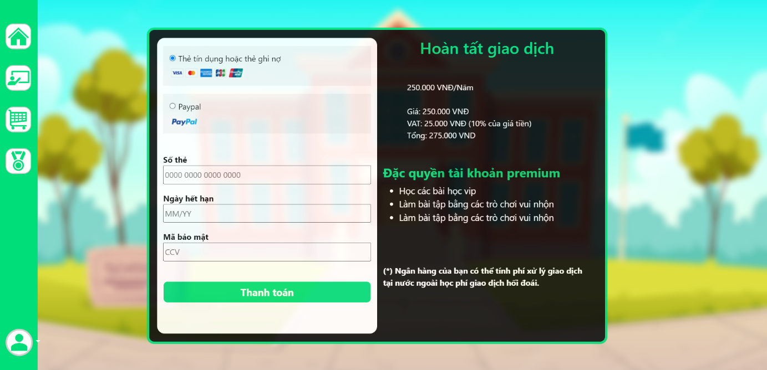

### n. Confirm payment:

* Function trigger: When user fill success payment, you will receive code in email.
* Function description:

- Customer roles will have access to this screen.

- This screen notifies to user to enter code which have 6 numbers. The code is in their email that we sent to.

-User need to fill the code in 2 minutes or the code will be expired.

Screen layout:

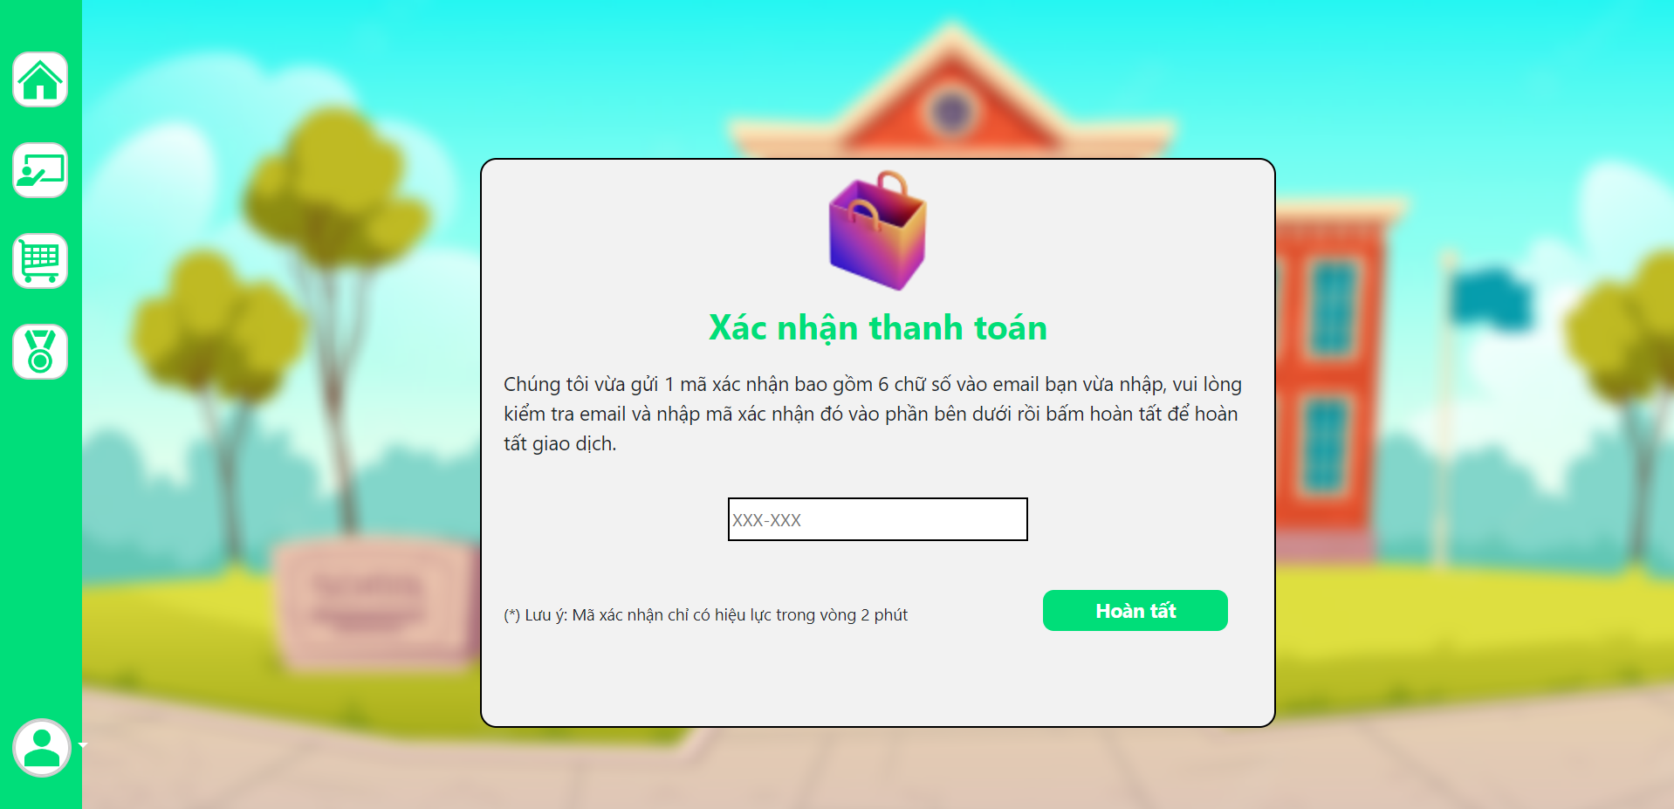

### o. Email payment:

* Function trigger: When user verify their payment.
* Function description:

- Customer roles will have access to this screen.

- This screen notifies to user that user have to fill email to confirm to pay

-User need to fill their email address and click to send code to pay.

Screen layout:

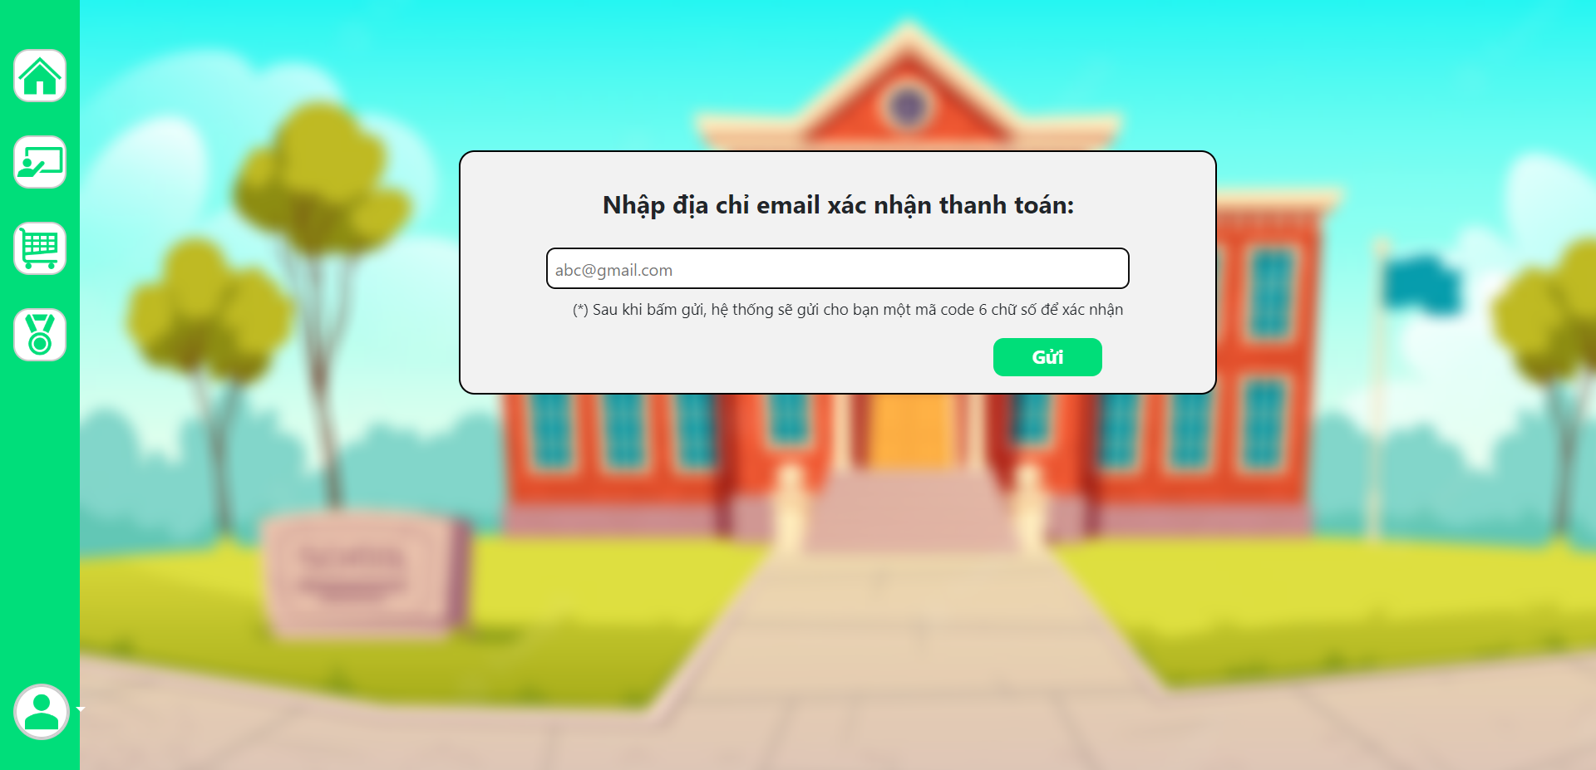

### p. User profile:

* Function trigger: When user click “Hồ sơ người dùng ” at home page.
* Function description:

- Customer roles will have access to this screen.

- Show navigation bar: Home, class, ranking, payment, profile.

- Show all information about user which include: Full name, date of birth, gender, parent’s name, parent’s email, phone number, user id, type of account.

Screen layout:



### q. Change user profile:

* Function trigger: When user click change user profile in user profile.
* Function description:

- Customer roles will have access to this screen.

- Show navigation bar: Home, class, ranking, payment, profile.

- User can change information which include: Full name, gender, date of birth, parent’s name, parent’s email, phone number, user id, type of account.

- User press save to save new information.

Screen layout:



### r. Change password:

* Function trigger: When user click “đổi mật khẩu” in user profile.
* Function description:

- Customer roles will have access to this screen.

- Show form which include old password, new password, confirm new password.

- User need to fill valid password.

Screen layout:

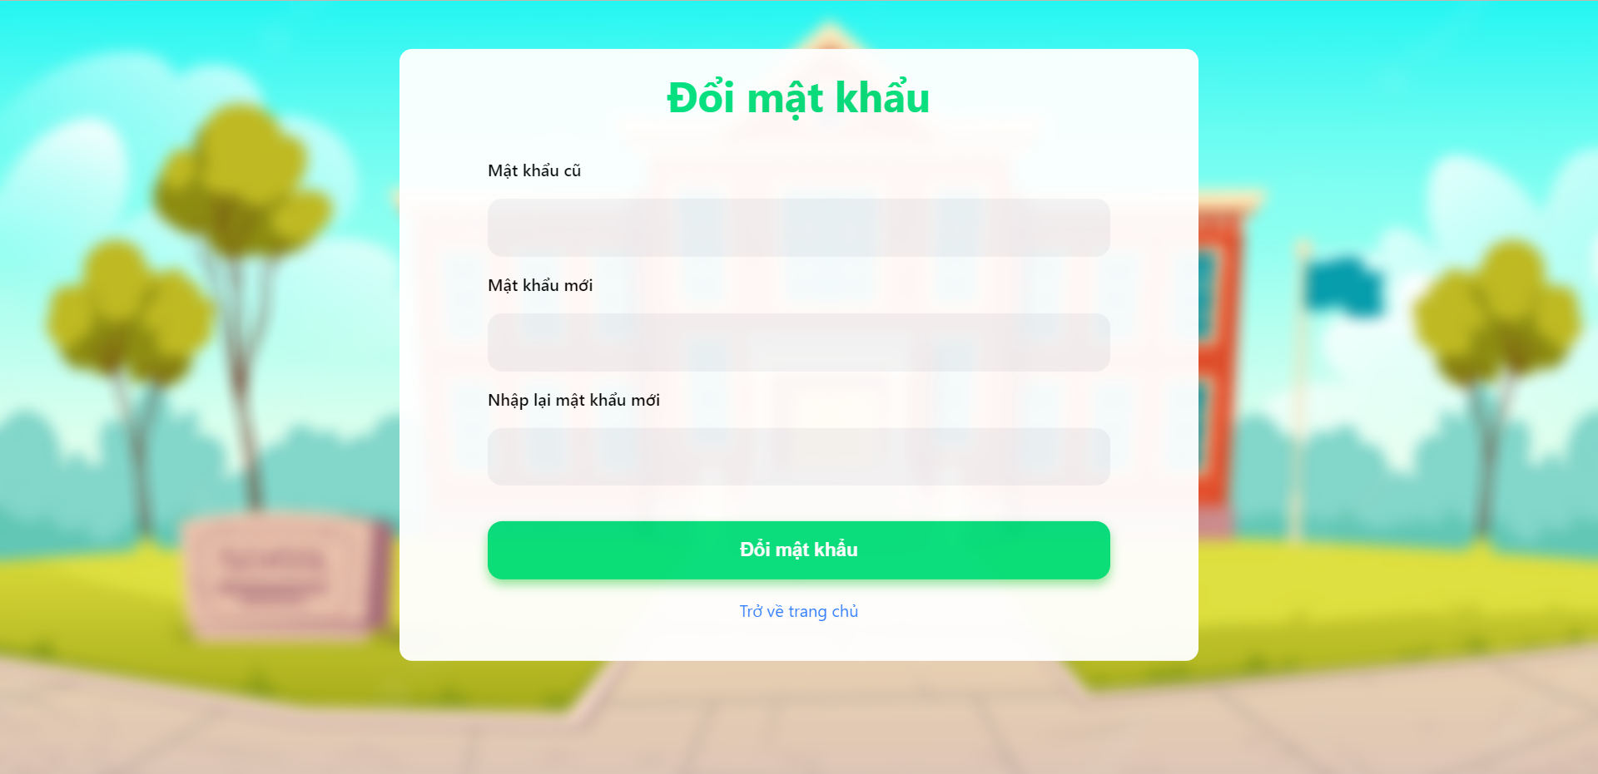

### s. Ranking:

* Function trigger: When user click “Ranking” at home page.
* Function description:

- Customer roles will have access to this screen.

- Show navigation bar: Home, class, ranking, payment, profile.

- Show ranking point, index.

- User can search by name to find their ranking and point.

Screen layout:



## 3. Admin feature:

### a. Manage quiz:

* Function trigger: When admin click manage quiz.
* Function description:

- Customer roles will have access to this screen.

- Show form which admin choose class, course, chapter, lession that admin want to add or delete quiz.

- After fill the form, admin press “Hoàn Tất” to add quiz.

- After choose question, admin press “Xác nhận và xóa” to delete quiz.

Screen layout:

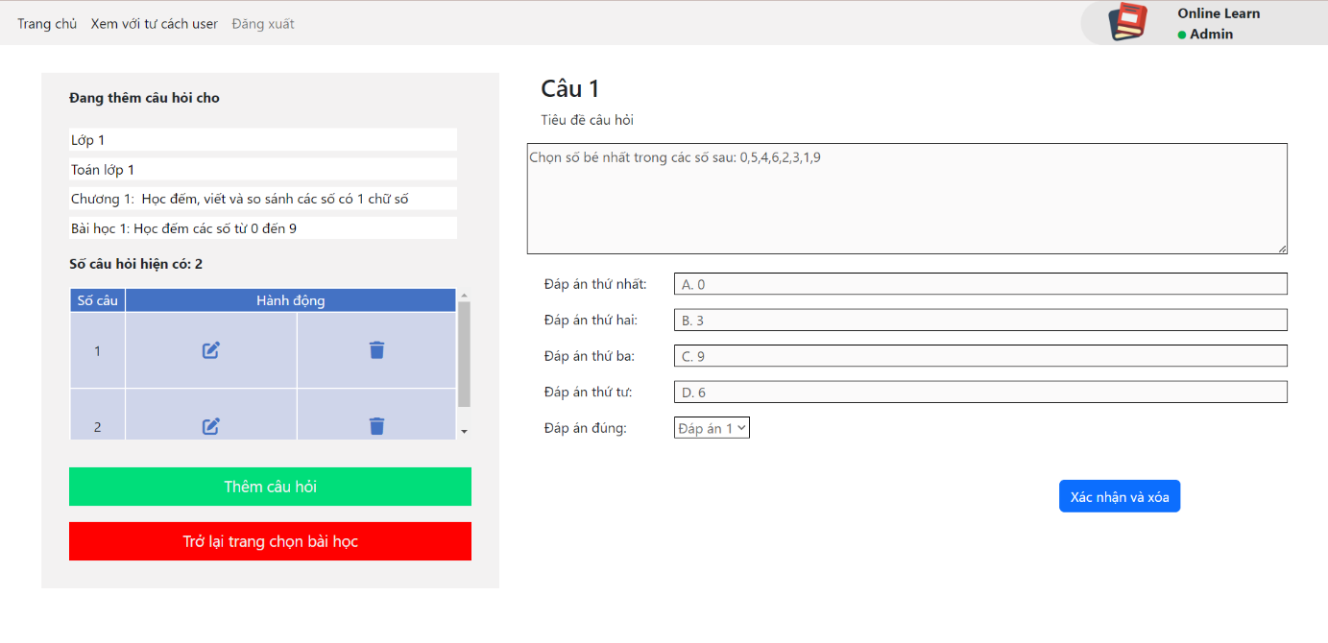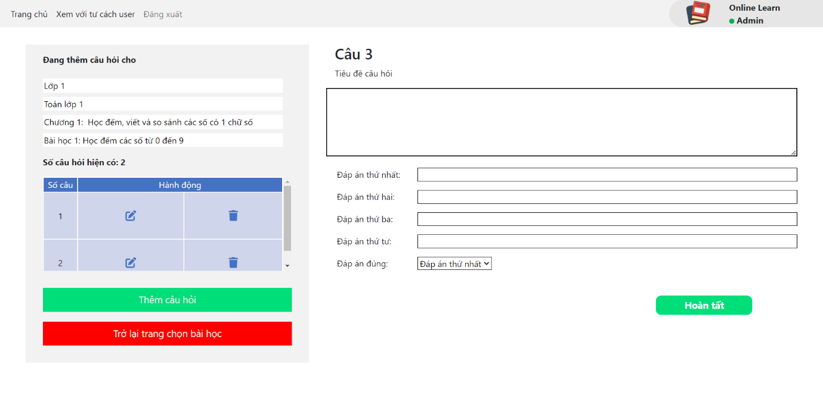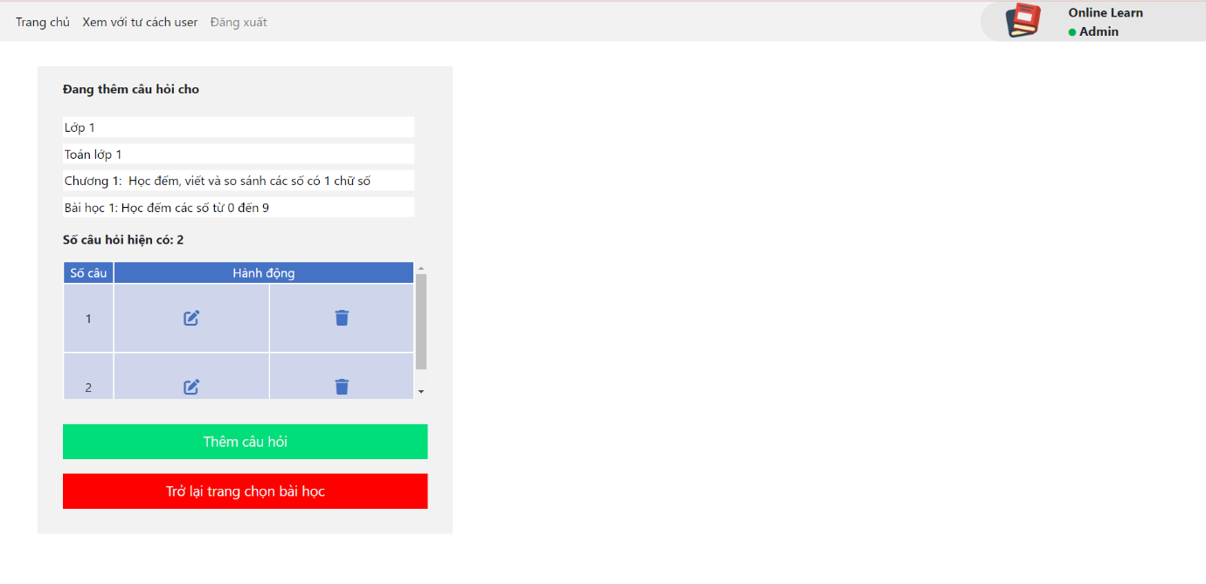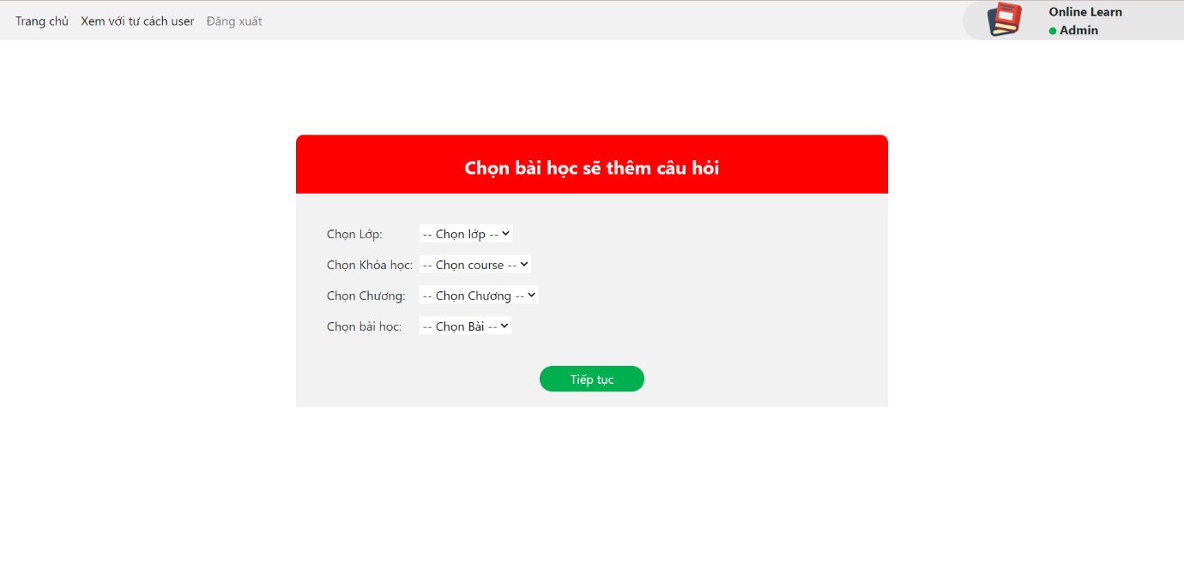

### b. Manage games:

* Function trigger: When admin click manage games.
* Function description:

- Customer roles will have access to this screen.

- Show form which admin choose class, course, chapter, lession that admin want to add pictures for game.

- After fill the form, admin press “Hoàn tất” to add pictures.

Screen layout:

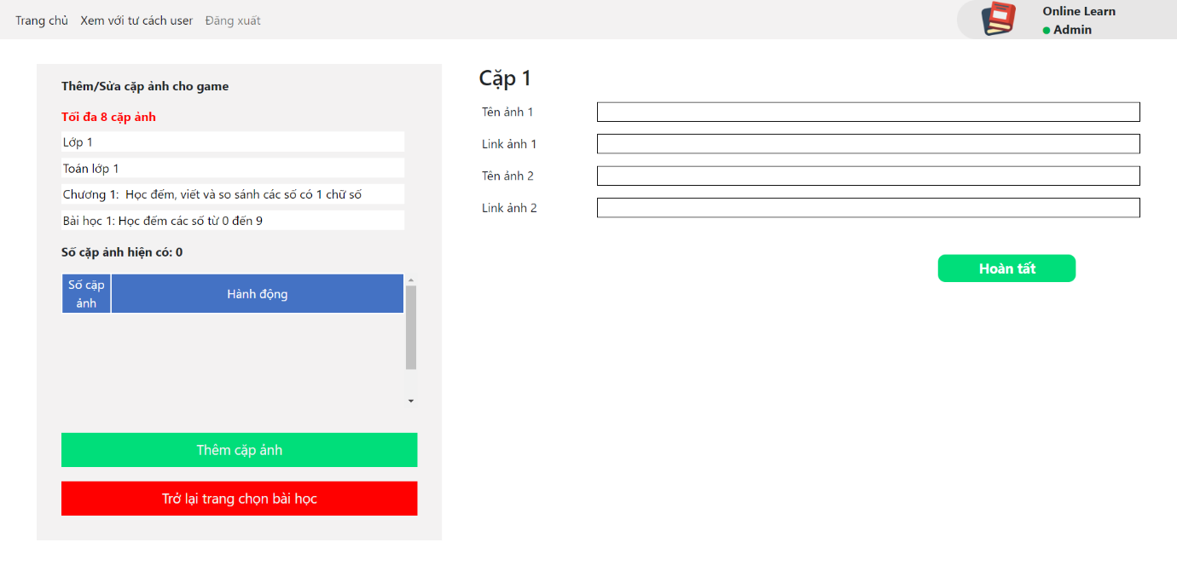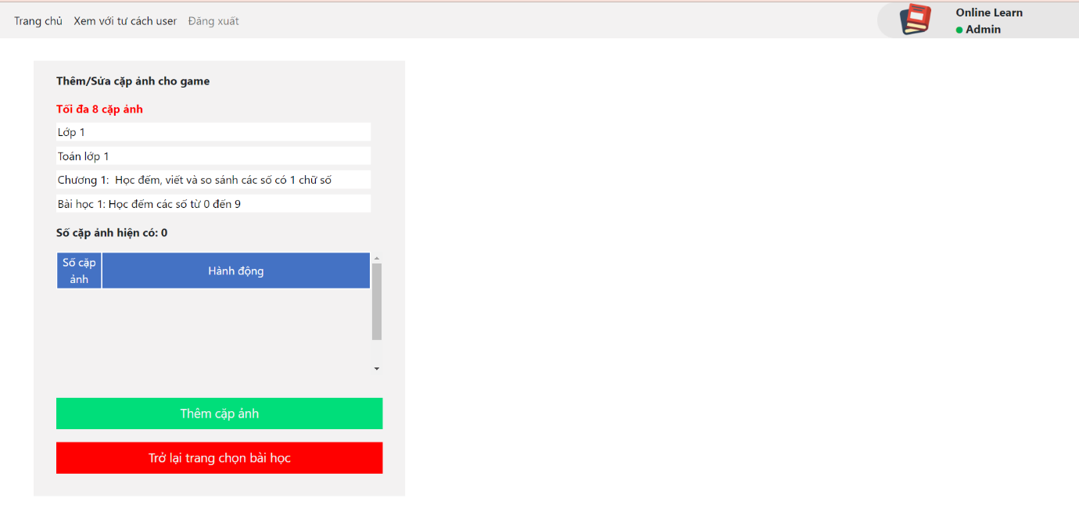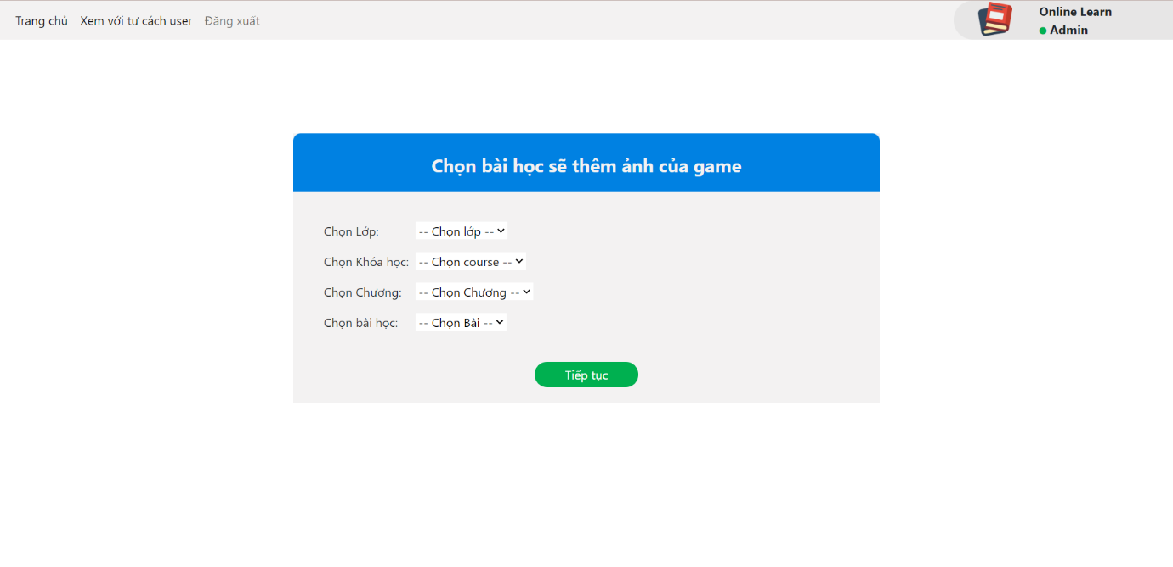

### c. Manage video lession:

* Function trigger: When admin click manage video lession.
* Function description:

- Customer roles will have access to this screen.

- Show form which admin choose class, course, chapter, lession that admin want to add or delete quiz.

- After fill the form, admin press “Hoàn Tất” to add quiz.

- After choose question, admin press “Xác nhận và xóa” to delete quiz.Screen layout:

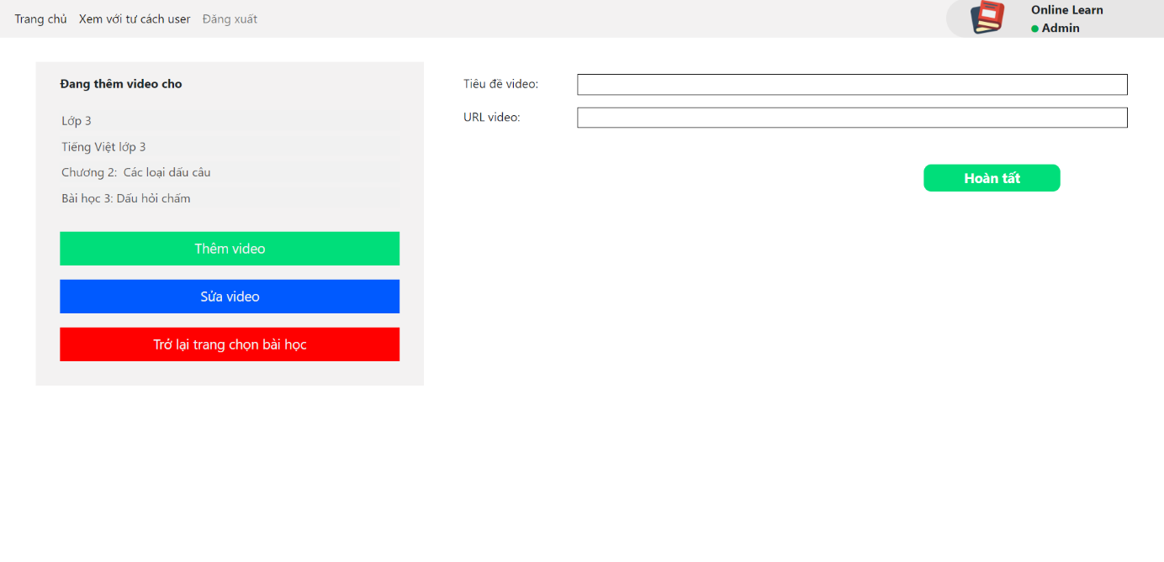

### d. Manage content:

* Function trigger: When admin click manage content.
* Function description:

- Customer roles will have access to this screen.

- Show form which admin choose class, course, chapter, lession that admin want to add/edit content.

- After fill the form, admin press “Hoàn tất” to add content or edit content.

Screen layout:

### e. Manage user:

* Function trigger: When admin click manage user.
* Function description:

- Customer roles will have access to this screen.

- Show total account which include normal account and premium account.

- Show list of account information which include: Full name, date of birth, gender, parent’s full name, parent’s email, parent’s phone number and usernamme.

- Admin can search by name account.

Screen layout:

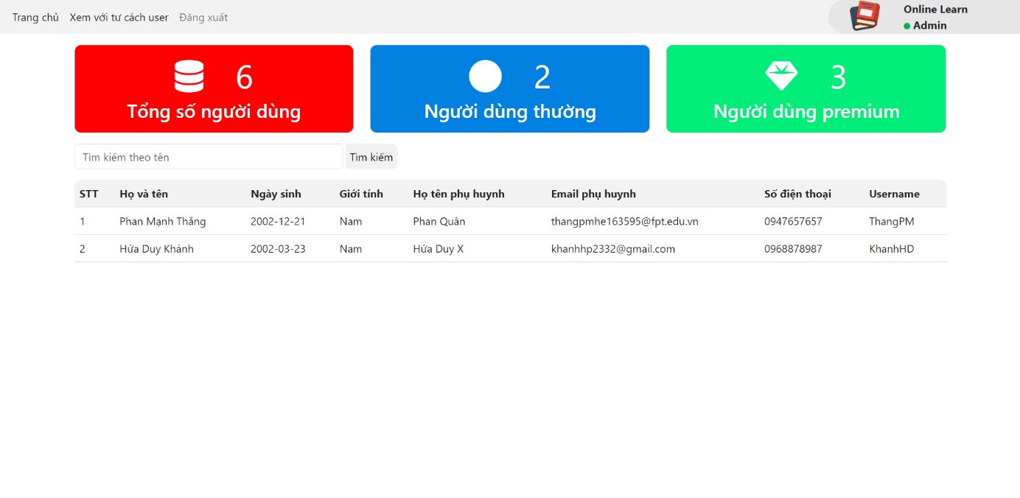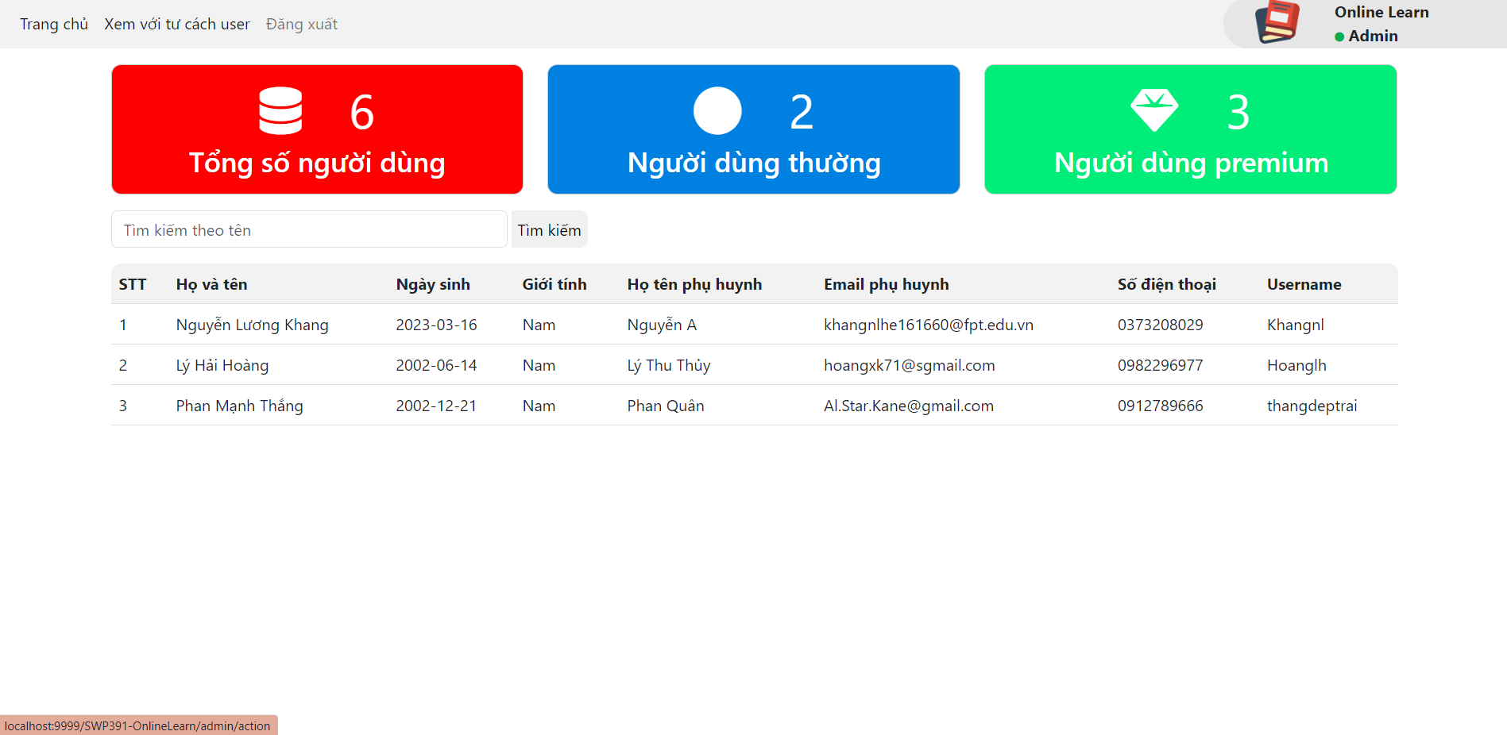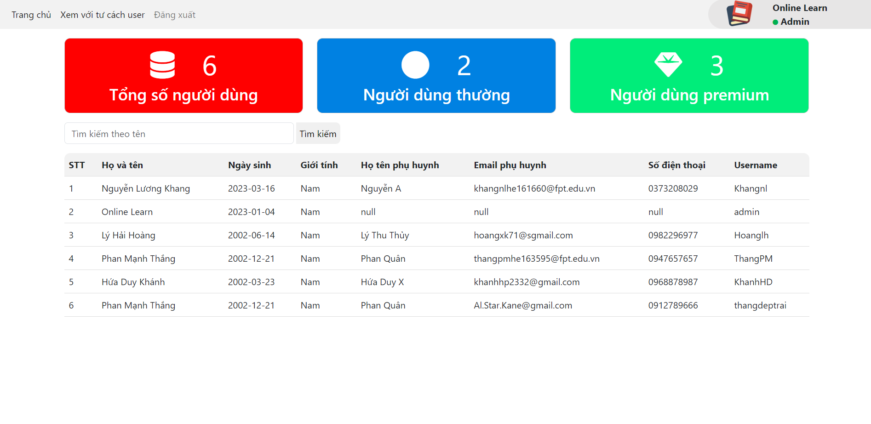

### f. Add/modify chapter:

* Function trigger: When admin click add/modify chapter:
* Function description:

- Customer roles will have access to this screen.

- Show form which admin choose class, course, chapter that admin want to add or modify chapter.

- After fill the form, admin press “Hoàn tất” to add or modify chapter.Screen layout:

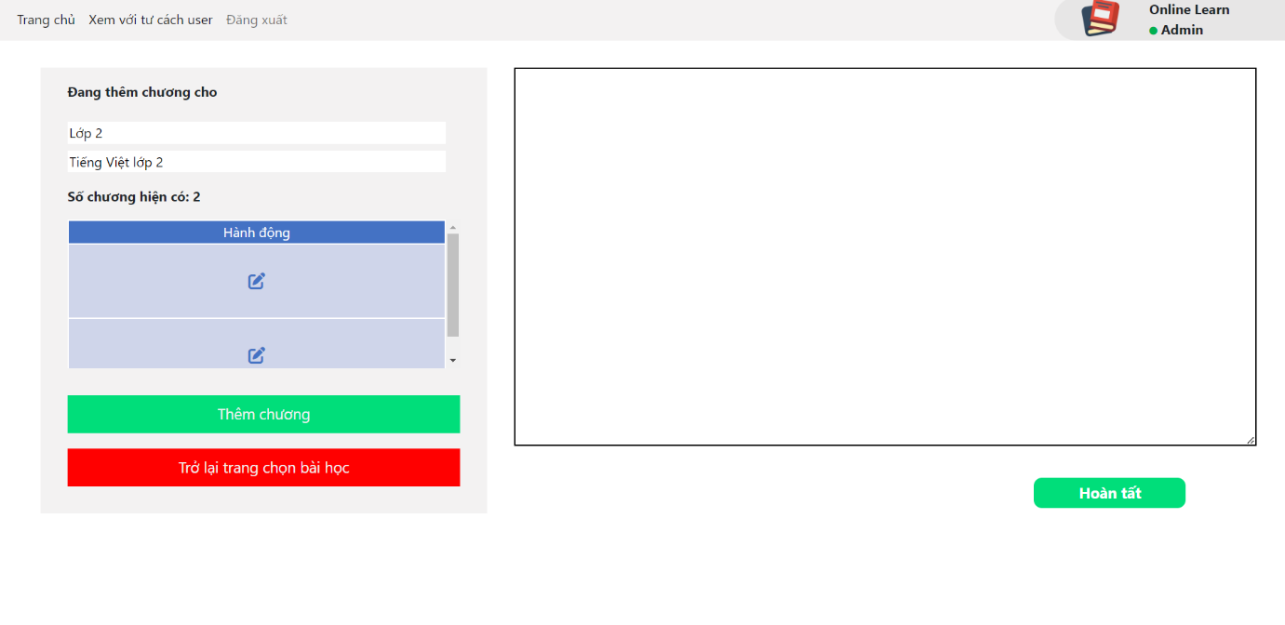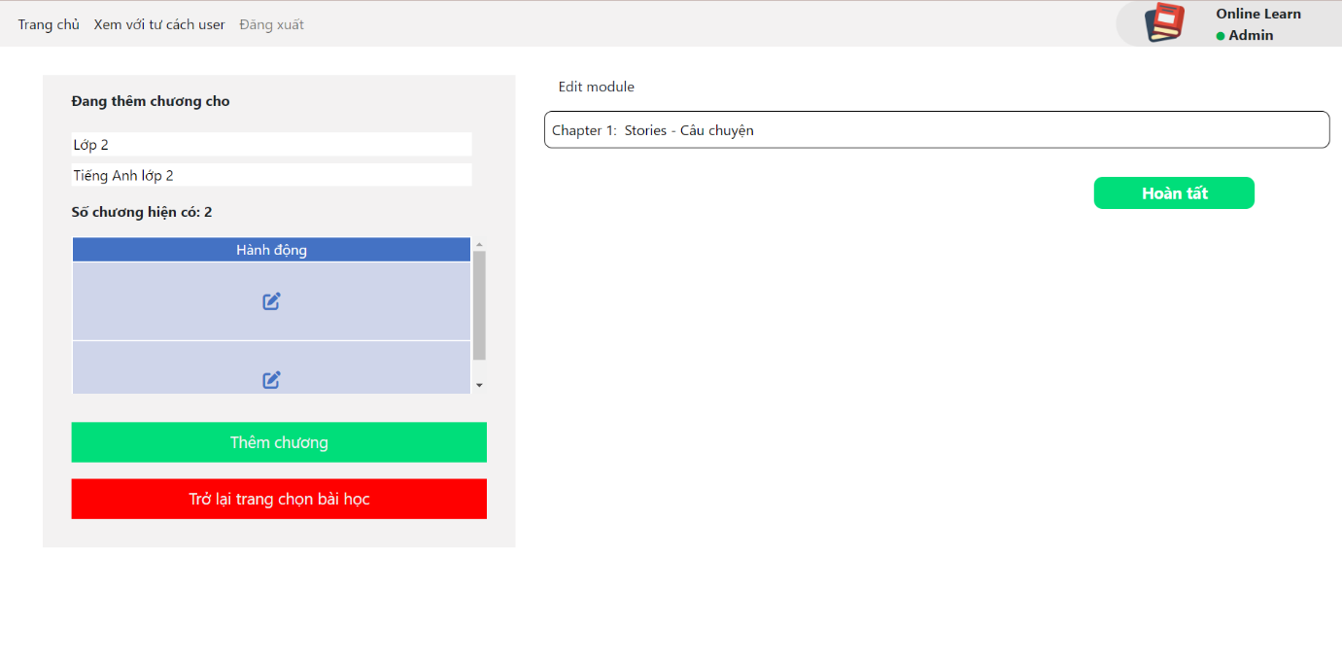

### g. Add/modify lession:

* Function trigger: When admin click add/modify lession
* Function description:

- Customer roles will have access to this screen.

- Show form which admin choose class, course, chapter that admin want to add or modify module.  
- After fill the form, admin press “Hoàn tất” to add or modify module.Screen layout:

